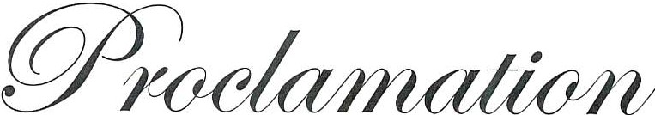
STATE OF NEW MEXICO EXECUTIVE OFFICE SANTA FE, NEW MEXICO

WHEREAS, New Mexico enacted the white cane law in 1967, becoming the first state in the nation to adopt the model white cane law; and
WHEREAS, The White Cane Law, 28-7-1 NMSA (1978), declares that it is the policy of the State to encourage and enable persons who are blind or visually impaired to participate fully in the social and economic life of the state, and to engage in remunerative employment; and
WHEREAS, The White Cane Law gives persons who are blind or visually impaired the same rights as all citizens to the full and free use of the streets, highways, sidewalks, walkways, public buildings, public facilities, and other public places; and
WHEREAS, The White Cane Law gives persons who are blind or visually impaired full and equal accommodations, advantages, facilities, and privileges of all common carriers, airplanes, motor vehicles, railroad trains, motor buses, streetcars, boats, any other public conveyances or modes of transportation, hotels, lodging places, places of public accommodation, amusement or resort, and any other places to which the public is invited; and
WHEREAS, The White Cane Law requires that drivers shall take all necessary precautions to avoid injury to pedestrians who are using a white cane or a guide dog; and
WHEREAS, it is important for all New Mexicans to be aware of The White Cane Law; to be aware that persons who are blind or visually impaired use the white cane to travel on public streets, roads, and at places of public accommodation; to be aware that persons with disabilities have much to offer and that their energy, creativity, and hard work greatly strengthens our state and our economy; and to recognize that the white cane is an instrument of safety and independence for persons who are blind or visually impaired.
NOW THEREFORE, I, Michelle Lujan Grisham, Governor of the State of New Mexico, do hereby proclaim October 15, 2023 as:
"White Cane Awareness Day"

throughout the state of New Mexico. Attest:

Maggie Toulouse Oliver
Secretary of State

Done at the Executive Office this 21st day of August 2023.

Witness my hand and the Great Seal of the State of New Mexico.

Michelle Lujan Grisham
Governor

