New Mexico Commission for the Blind
MINUTES (Draft)

Special Meeting Held Virtually
February 24, 2023 - 9:00 AM

1. Call to Order

Chairperson Lansing called the meeting to order at 9:00 AM.

2. Roll Call

Chairperson Lansing took roll, and Art Schreiber and Shirley “Urja” Lansing were present. Robert Reidy was absent.

3. Introduction of Guests and Staff

Staff present were Greg Trapp, Executive Director; Jim Salas, Deputy Director for Vocational Rehabilitation and Independent Living; Kevin Romero, Deputy Director for Finance and Administration; Jamie Sibson, Orientation Center Director; Kelly Burma, Skills Center Coordinator and SRC Liaison; Daphne Mitchell, Vocational Rehabilitation Program Manager; Patricia Savage, Executive Secretary; Janelle Gonzales, Finance Manager; and Lucy Mallahan, Special Projects Manager. Also present was Liza Kerr, Finance Audit Director from the Office of the State Auditor. Present also was Jeff Blair, Former Commissioner and SRC member.

4. Approval of Possible Changes to the Agenda Order and Tabling of Agenda Items

There were no changes to the agenda.

5. Approval of Minutes for the Meeting of February 8, 2023

Mr. Schreiber motioned to approve the February 24, 2023 minutes, and Chairperson Lansing seconded the motion. A roll call vote was taken, and the minutes were approved with Mr. Schreiber and Chairperson Lansing all voting yes. Dr. Reidy was absent for this vote.

6. Chair Report, Shirley “Urja” Lansing

Chairperson Lansing said she did not have a report.

7. Director's Report, Greg Trapp

Mr. Trapp said Senate Bill 437 will be heard this morning by the Senate Rules Committee. He said the bill would create a commission of vocational rehabilitation for
the current Division of Vocational Rehabilitation. He said this is a bill that has been introduced before. He said the agency submitted a fiscal impact report on the Bill. He said the bill is using very old legislative language. He said section 19 would transfer property belonging to the School for the Blind to the Commission on Vocational Rehabilitation. He said he thinks the language is left over from the 70’s or 80’s, when school for the blind properties were transferred to the Bureau of Blind Services within the Division of Vocational Rehabilitation. He said there is no reason to have that language, adding it could have some unintended consequences. He said the Albuquerque office and Alamogordo Orientation Center building once belonged to sheltered shops associated with the School for the Blind, saying the Commission is now using them to further competitive employment. He said there were other issues with the bill, adding the Commission expressed those concerns in the fiscal impact report.

Mr. Trapp said the Commission will conduct three public meetings on March 9. He said two meetings will be virtual and one meeting will be hybrid. He said one reason for the meetings is to get comments on the Manual of Operating Procedures. He said one proposed change to the Manual of Operating Procedures is to increase the amount of maintenance paid to consumers attending training at the Orientation Center. He said the agency will distribute the list of proposed changes. He said the Commission will also be soliciting comments on the State Plan as well as the rate setting methodology guide that has been issued by the Vocational Rehabilitation Technical Assistance Center and the Rehabilitation Services Administration. He said the guide encouraged vocational rehabilitation agencies to solicit public comment on the rates that are paid for vocational rehabilitation services and systems. He said the Commission will be sending information on the public meetings out to the Independent Living Centers, the 121 Native American Rehabilitation programs, Disability Rights New Mexico, and the National Federation of the Blind. He said meeting notices will also be put on Newsline.

Mr. Trapp asked Ms. Sibson and Ms. Mallahan to talk briefly about the Orientation Center apartments, and Ms. Sibson said the apartments are coming along nicely and are close to completion. She said canopies are being installed in the patio area between the dorm and the apartments, mailboxes are being installed, and sidewalks are being repaired. She said furniture, washers, dryers, and blinds will be put into the apartments once they are received. She said she hopes to get the apartments up and running by April. Ms. Sibson said there has been discussion on a ribbon cutting ceremony or open house, and the tentative date for that will be April 5 or April 6.

8. Unfinished Business

a. Update on Rehabilitation Services Administration Annual Review Finding on Pre-Employment Transition Services, Greg Trapp, Kevin Romero, and Jim Salas

Mr. Trapp said this item relates to a Rehabilitation Services Administration finding on the state’s spending of the Pre-Employment Transition Services reserve. He said the finding followed a Program Determination Letter that was issued to the Division of Vocational Rehabilitation on the spending of the Pre-ETS reserve. He said the Annual Review found the State did not meet the Pre-ETS reserve in FY20 by a significant amount. He said most of the inability to spend the reserve was related to the pandemic. He said DVR revised their SF-425 report after the finding, and the revised report showed a much greater amount of Pre-ETS spending. Mr. Trapp said the pandemic shut down schools and made it impossible for the Commission to run the STEP program out of the Orientation Center and Skill Center. He said as a result the Commission ended up spending less on Pre-ETS. He said the pandemic was an extraordinary circumstance. He said with the amended SF425 report, the State came substantially closer to meeting the Pre-ETS reserve. He said the revised report showed the state spent 84.15 percent of the Pre-ETS reserve, missing the reserve by just $649,000. He said the Pre-ETS spending was good considering the pandemic. He said the State was back on track with Pre-ETS spending in Federal FY21. He said RSA asked the state to develop a Corrective Action Plan, but in light of the revised SF425 report, and looking at spending patterns in Federal FY19, Federal FY20 and Federal FY21, both the Commission and DVR thought a Corrective Action Plan was not necessary. He said a response was sent to RSA saying that the revised SF425 report showed the State had come within $70,000 of meeting the Pre-ETS reserve in 2021, and that a Corrective Action Plan was no longer necessary since corrections had already been put in place.

Mr. Salas said the total reserve and expenditure requirement for the State is $3.75 million, and between the Division of Vocational Rehabilitation and the Commission roughly $3.15 million was spent on Pre-ETS.

Mr. Romero said when this matter was brought to the Commission’s attention, the Commission reviewed the reports for Federal FY19, Federal FY20, and Federal FY21. He said the review showed the Commission reported accurate and correct numbers, with the supporting documentation supporting those numbers.

Mr. Trapp said the Commission has increased Pre-ETS spending by putting in place additional contracts. He said the pandemic has eased, and the state should meet the Pre-ETS reserve requirement this year.

Chairperson Lansing acknowledged the diligence of the Commission’s Financial team for excellent recording and tracking.

9. New Business

a. Acceptance of State Fiscal Year 22 Audit, Liza Kerr, Financial Audit Director, Office of the State Auditor

Mr. Trapp said the audit is a cooperative process, and the agency sees the audit as an opportunity to make sure that the Commission is compliant and continually improving with respect to accountability.

Mr. Romero introduced Liza Kerr from the Office of the State Auditor, saying she will be presenting the Commission’s State FY22 audit.

Ms. Kerr said she will be sharing some required information with the Commission. She said Elena Tercero was the primary lead on this audit and held co-roles as Financial Audit Manager and Co-Deputy State Auditor and Ms. Kerr had co-roles as the Financial Audit Director and the Co-Deputy State Auditor. Ms. Kerr said the timeline for the financial statements to be submitted was no later than November 1, 2022. She said the Office of the State Auditor has audited the FY22 financial statements of the New Mexico Commission for the Blind, the financial audit and the compliance audit, which is the Federal piece. She said the audit was conducted in accordance with governmental standards and the New Mexico audit rule, and 2 CFR Part 200 Uniform Guidance. She said management prepared the MDNA, the financial statements and the supporting schedules included in the report. She said the Office of the State Auditor issued an unmodified opinion on the financial statements as a whole, and each opinion unit which included the governmental activities, business type activities, general fund 04700, proprietary fund 110460, and budgetary comparison for the general fund. She said the Office of the State Auditor issued an unmodified opinion on compliance for the major program tested, which was Federal compliance. She said the Office of the State Auditor has some required communications with governance at the conclusion of the audit, which includes fraud communications. She said the audit staff must let the Commission know that fraud inquiries were held with key management personnel and other employees during the audit. She said the auditor is responsible under generally accepted auditing standards to design the audit to provide reasonable, but not absolute assurance, and the management is responsible for the financial statements. She said management is responsible for the selection and use of appropriate accounting policies. She said accounting principles utilized by the Commission for the Blind are appropriate and have been consistently applied. She said there were no policies adopted related to controversial areas or accounting practices implemented with lack of guidance or consensus. She said all significant transactions have been recognized in the financial statements. She said the disclosures are neutral, consistent, and clear, and there were no significant difficulties encountered in the performing of the audit. She said there are no uncorrected misstatements or corrected misstatements, as a result of audit procedures. She said there were no disagreements with management. She said there were no instances of non-compliance, material to the financial statements identified. She said in regard to prior year findings, there was one finding last year, that addressed controls over capital assets, however, that finding was cleared in the current year. She said in the current year there were no findings noted. Ms. Kerr said there were quite a few new standards effective for 2022, which had been put off during the pandemic, making it a very challenging year. She said the standard that was most significant is GASB 87. She said there were several GASB 87 leases, and the staff did great analysis, and the standard was implemented for the year. She said GASB statement 96 Subscription Based Information Technology Arrangements will be relevant to the Commission for the Blind. She said the number of Subscription Based Information Technology Arrangements the Commission has will determine how complicated it is to implement. Ms. Kerr thanked the Commission staff for their hard work and efforts during the year, saying it was really appreciated and very much noted.

Mr. Romero thanked Ms. Kerr for the presentation and the kind words. He said that both the Office of the State Auditor team and the Commission for the Blind team excelled very well this last year.

Mr. Trapp also thanked Ms. Kerr for the report and Mr. Romero and Ms. Gonzales for their hard work.

Chairperson Lansing thanked Director Kerr and all of her staff for working with the Commission. She also thanked Mr. Romero, his staff and the entire Commission staff for all their hard work. Mr. Schreiber thanked the Office of the State Auditor, Mr. Romero and his staff, and Mr. Trapp and his staff for an outstanding job on the audit.

Mr. Trapp said the Commission has a great team working to make things go smoothly. He said the Commission’s program is incredibly complex and he is very proud the Commission did not have any audit findings.

Ms. Gonzales said the Commission has a great staff who work very hard and very well together and are very much appreciated. Ms. Gonzales thanked the Office of the State Auditor’s staff for working with the Commission on the audit.

Mr. Schreiber motioned to approve the FY22 Audit, and Chairperson Lansing seconded the motion. A roll call vote was taken, and the FY22 Audit was approved with Mr. Schreiber and Chairperson Lansing all voting yes. Dr. Reidy was absent for this vote.

b. Report of Property Disposition Committee, Kevin Romero

Mr. Romero said during the last meeting he had given an update that the committee was working on a request that was received from the Orientation Center to dispose of equipment that had been deemed no longer usable, repairable, and was not functional for the Commission. He said there were also requests to dispose of equipment by the Business Enterprise Program. He said that New Mexico State Surplus denied all requests and will not be accepting any of the equipment. He said the Business Enterprise Program equipment will be disposed of through auction, 30 days after the notification to the Office of the State Auditor, as required by law. He said that notification was sent out yesterday, so March 25 would be the earliest the Commission could dispose of the equipment. He said the other two notifications will go out today, February 24, and the earliest disposal date will be March 26, 2023. He said copies of the record for this meeting will be provided of all three notifications, and in March a copy of the release memos will also be provided as supporting documentation that the items were authorized for disposal.

10. Commission Open Discussion

There was no open discussion.

11. Comments from the Audience

Mr. Blair said the Commission has such an outstanding record in compliance and performance, and it is an honor to be able to serve on the State Rehab Council.

12. Date and Location of Next Meeting

The next meeting is scheduled for 9:00 AM on April 25, 2023. The meeting will be held in Albuquerque, and will be either in-person or virtual, depending on the pandemic. The following meeting was set for Albuquerque on August 23, 2023 at 9:00 AM.

13. Adjourn

The meeting was adjourned at 9:58 AM.

Approved and Electronically Signed this 25th Day of April 2023

Shirley Lansing, Chairperson
New Mexico Commission for the Blind

Attachment 1: Commission Letter to Office of the State Auditor
regarding property disposal

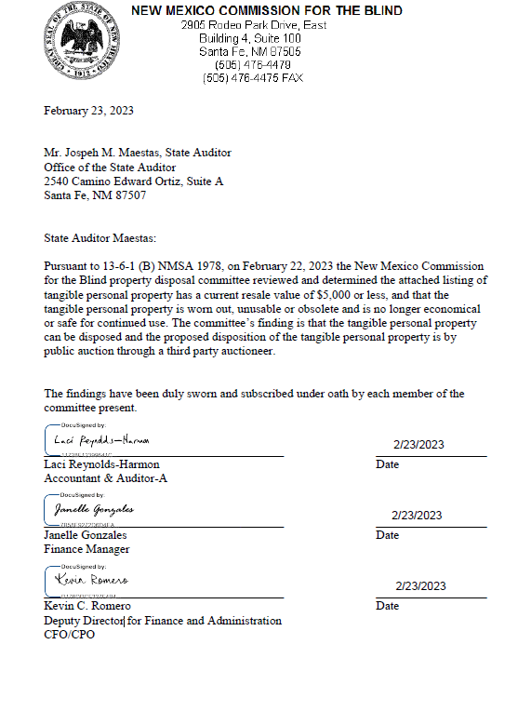
Attachment 2: List of Equipment for Auction January 2023

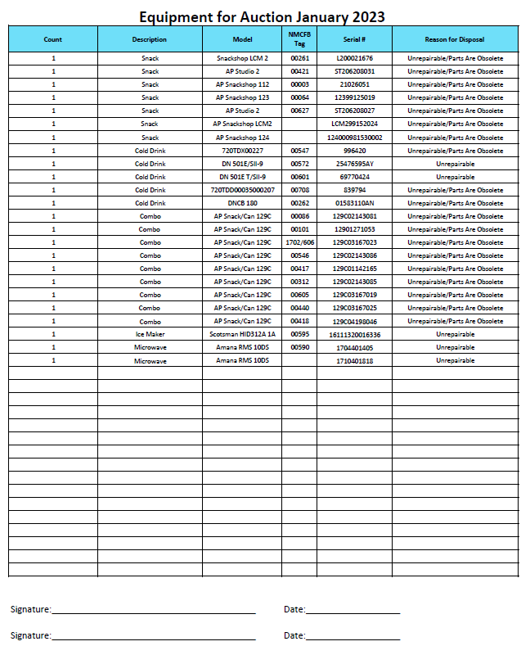

Attachment 3: Commission Second Letter to Office of the State Auditor
regarding property disposal

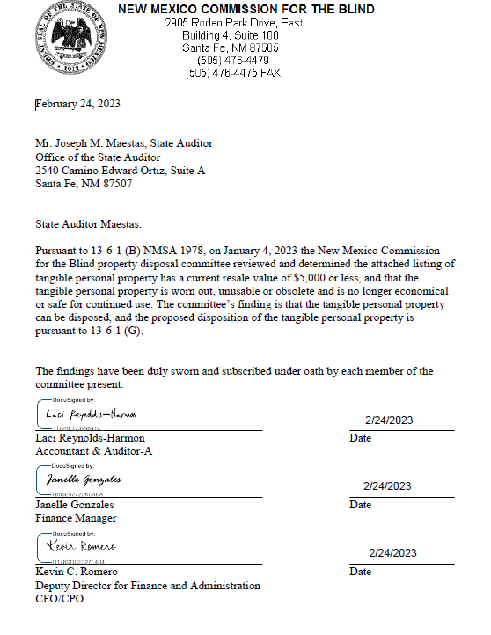
Attachment 4: Refusal Letter from NM State Agency Surplus Property

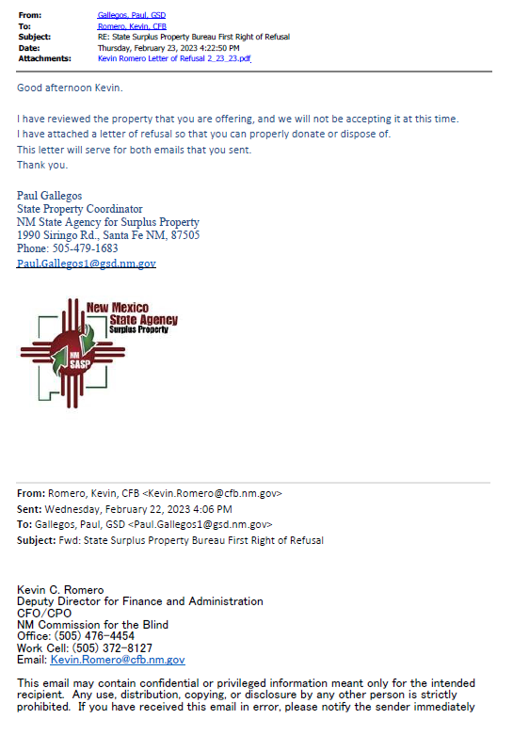
Page 2 – NM State Agency Surplus Property

