Commission for the Blind

Minutes (Final)

Regular Meeting

August 23, 2023 - 9:00 AM

Commission for the Blind
2200 Yale Blvd SE
Albuquerque, NM 87106

1. Call to Order

Chairperson Lansing called the meeting to order at 9:15 AM.

2. Roll Call

Chairperson Lansing took roll. Katharine Chavez, Robert Reidy, and Urja Lansing were present.

3. Introduction of Guests and Staff

Staff present were Greg Trapp, Executive Director; Kelly Burma, Skills Center Coordinator; and Patricia Savage, Executive Secretary. Audrey Trujillo, Information Technology Manager, and Kevin Romero, Deputy Director for Finance and Administration, were delayed by traffic and joined the meeting later. Daphne Mitchell, Vocational Rehabilitation Program Manager, also joined the meeting later. Coby Livingstone attended by Zoom, and Diana Marquez was present.

4. Approval of Possible Changes to the Agenda Order and Tabling of Agenda Items

Mr. Trapp asked for a motion to approve the agenda, allowing for Mr. Romero’s items to be moved to accommodate his delayed arrival, specifically the Administration and Finance, Budget, and the Property Disposition reports.

Dr. Reidy moved to approve the agenda as revised, and Ms. Chavez seconded the motion. A vote was taken, and the revised agenda was unanimously approved.

5. Approval of Minutes for the Meeting of April 25, 2023

Ms. Chavez moved to approve the April 25, 2023, minutes. Dr. Reidy seconded the motion. A vote was taken, and the minutes were unanimously approved.

6. Chair Report, Shirley “Urja” Lansing

Chairperson Lansing said the 2022 Annual Reports will be distributed today. She asked that the Commissioners share them with Optometrists, Ophthalmologists, and others who need to know about the services of the Commission. She invited the public to attend the State Rehabilitation Council special meeting, which will be held on August 31 starting at 9:00 AM. She said the purpose of the meeting will be to go over the Agency's goals and priorities and other items relating to the State Plan. Chairperson Lansing said Director Trapp will be holding a public meeting at the National Federation of the Blind State Convention on September 23, starting at 11:00 AM. She said Director Trapp will be giving the Commission report later that afternoon.

7. Director's Report, Greg Trapp

a. Major Trends and Developments, Greg Trapp

Mr. Trapp said it was great to have the Commissioners all attending in person. He said the Commission is in a very good place, with all VR Counselor positions filled, with the state exiting the pandemic, and with spending and services coming back to normal.

Mr. Trapp said the Commission has historically been represented by the Attorney General's Office, and that John Kreienkamp very ably represented the Commission. Mr. Trapp said the Commission is still waiting for a new attorney to be assigned to the board. He said the Office of the Attorney General is understaffed, but an attorney should be assigned to the board soon. Mr. Trapp said the Commission is not without representation, saying the agency has Mr. Quentin Smith as a contract attorney. Mr. Trapp said Mr. Smith is very capable and that he has represented many state agencies.

Mr. Trapp said there have been significant developments at the national level with respect to interpretation of regulations. He said the most significant of those took place on June 23 when the Rehabilitation Services Administration issued what was called a Dear Colleague Letter. He said the feds were reinterpreting the definition of the word recipient in terms of how the state match was to be met. He said under this new definition agencies will no longer be able to carry over federal funds if the state as a whole has not met the state match requirement. He said in the past if an agency had met the match for its federal funds, those federal funds could be carried over into the next year. Mr. Trapp said that while the Commission might have put up enough match, if DVR does not put-up sufficient match on their side, then the state as a state may be unable to carry over federal funds. He said the Commission had planned on carrying over about $350,000 or $400,000 in FFY 23 funds. He said the Commission is doing all it can to meet the FFY 23 match requirements and hopes to be able to carry over funds.

Mr. Trapp said the National Council of State Agencies for the Blind sent a letter to the Rehabilitation Services Administration about the new interpretation. He said the interpretation was issued without any public comment, and that the Administrative Procedures Act normally requires that agencies interpreting federal legislation have to first take public comment. He said federal agencies are given broad latitude to interpret their own rules, but in this case, RSA is interpreting a statutory definition of recipients. He said the federal government may believe this interpretation will allow for greater funds to be drawn. He said if there was a year when the Commission was not able to put up all of the state funds, and if DVR has put up an excess of state funds, then the Commission might be able to carry over funds. He said the Commission will have to work very closely with DVR with respect to match issues. He said that half of state funds spent on construction of VR facilities could also be used for match.
Mr. Trapp said that RSA issued RSA-TAC-23-0 on July 11. He said it encouraged VR agencies to spend additional federal revenues and to take advantage of the flexibility that have been given. He said he was very pleased with the TAC, and that the Commission has long operated in the way encouraged by the TAC, including eliminating the financial needs test. He said the financial needs test imposed an unnecessary burden on staff. He said the TAC allows 4 years of extended services for youth with the most severe disabilities. He said he thought the TAC was in response to VR agencies turning back a half billion dollars.
Mr. Trapp described the efforts by the Department of workforce Solutions to better align the state’s workforce case management systems. He said the Commission uses a system called AWARE, and that the Commission is very pleased with AWARE, and especially its report writing functions. He said 41 VR agencies across the nation use AWARE, with 36 states using AWARE. He said the AWARE system would be demoed to DWS on August 31. Ms. Audrey Trujillo agreed with Mr. Trapp’s comments.
Mr. Trapp concluded by describing the Combined State Plan Process, saying the SRC would be meeting on August 31. He described the public input process, including DWS holding public meetings through Zoom. He said the agency distributed notices about the public meetings through the NFB list and also to the SRC. He said the Commission is on track to get a draft of its portion of the Combined State Plan to DWS by the end of September. He said it has been a very labor-intensive and compressed process, and that it would normally be submitted towards the end of the year or early next year.

b. Administration and Finance, Kevin Romero

Mr. Romero apologized for being late. He reported on SFY 24 spending, saying that as of last night the Commission has spent 2,081,573 of its budgets, and has encumbrances of $525,428. He said these leaves $14,539,399, or 84.8% of the budget left to be spent. Mr. Romero said the agency is Keeping a close eye on VR expenses, including for Pre-ETS. He said the agency is confident it will be able to spend the Pre-ETS reserve for FFY 23.

Mr. Trapp told Mr. Romero he had already reported on the Dear Colleague Letter, and Mr. Romero said the Commission is working very closely with DVR now that match is determined on a state rather than agency basis. He said this includes Pre-ETS spending, and that he is confident the state as a whole will meet the Pre-ETS spending requirement. He said the Commission and DVR will be sharing spending information quarterly and when necessary, even sooner. Mr. Romero said the agency is in a very good position for SFY 24.

Mr. Romero reported on human resources, saying the agency currently has 15 vacant positions, with seven of those being classified. He said this gives the agency an overall 16.5 percent vacancy rate, and a 10.9 percent vacancy rate for classified positions. He said the agency is currently recruiting to fill all seven classified positions, and 2 exempt positions. He said the agency is budget at a 9.5 percent vacancy rate, and that he hopes to be blow that rate.

Mr. Romero reported on facilities, saying that as of August 1 the Las Cruces office has a new building lease, and will be moving into the new office by the end of the week. He said the new office will be better suited to the needs of the agency. Mr. Romero added that the agency was working to renew the Roswell lease, and that the agency does not have to go out for an RFP because the office size is less than 2,000 square feet. Mr. Romero reported on the Santa Fe office, saying the Las Vegas staff had been relocated to Santa Fe. He said an RFP for the Santa Fe office was released on August 21. He said he could not discuss it further because of the RFP rules. He concluded by saying the Santa Fe office would house administrative as well as field office staff.

Mr. Romero reported on the SFY 23 closeout, saying SFY was successfully closed. He said the fiscal staff were working with the audit staff to make needed audit period adjustments. He said the audit process has begun, and that the entrance conference will be held on August 28 at 10:00 AM. He said the fiscal staff are working to prepare and submit financial documents to the auditors. He said the goal is to have the audit submitted by the deadline of November 1, 2023. He said the goal is to have a clean audit with no findings. He said that the content of the audit would be confidential until it is released, which he said should be in early January.

Mr. Trapp asked Mr. Romero to talk about the just-completed relinquishment process, and Mr. Romero described relinquishment process, saying it allows agencies that cannot spend off of their VR grant to relinquish some of the grant so it can be used by VR agencies in other states. He said the agency did not relinquish any funds, but will instead match and carry over unspent FFY 23 funds to the second year of the period of performance. He said, if the Commission would have relinquished funds, the Commission would have first checked with DVR to see if DVR could use the funds. Mr. Romero said DVR relinquished $2.9 million, which will lower the match and Pre-ETS threshold for the state.

Mr. Trapp noted that Daphne Mitchell has joined the meeting, and he asked her to talk further about case alignment, saying she attended a case alignment meeting yesterday. Ms. Mitchell said it was a 4-hour meeting, saying it was facilitated by a person from the National Association of State Workforce Agencies. Ms. Mitchell said at the meeting She spoke on behalf of AWARE, saying the VR agencies do not have any issues with AWARE. She said AWARE is great and houses everything the agency needs for the Commission’s counselors and financial reports. She said there is concern with the system that the other workforce partners are using. She said the various systems are being demonstrated and assessed in the process. She quoted the Workforce Secretary as saying the state is not pushing for a single system, adding that the Governor is wanting the workforce system and partners to work better.

Mr. Trapp said case alignment is an important issue for the Commission because of the need for report writing, compliance, and case management functions. He said he is open to sharing allowable information and adding referrals, and that he is committed to being a good partner and will work with the state to make sure that the system is as seamless as it can be.

Independent Living and Vocational Rehabilitation, Jim Salas

Mr. Romero read a report from Mr. Salas, who was unable to attend due to illness. A summary of the report from Mr. Salas is as follows:

Deon Dodson is retiring on September 29 from the Farmington BSI position. Deon has been with the Commission since April 1998. He has been a great employee and has been very effective in serving his territory. The agency is reviewing the first list of applicants for the vacant position. The Commission is conducting a second-round interview tomorrow to fill behind Barbara Kane for the Las Cruces BSI position. She resigned in June for family reasons.

The Commission is upgrading the types of video magnifiers that are provided to independent living and Older Blind consumers. The Commission has been providing SmartLux handheld units, but is now considering a mid-size portable unit with a 12 to 13 inch display. The Commission is also ordering desktop units with a 21-inch display.

The STEP program Started with 35 participants and finished with 32. Reporting on employment numbers for State Fiscal Year 23, the final number for competitive integrated was 26, for self-employment was 1, making a Total of 27 for the year. The Average hourly wage was $22.90. For Federal Fiscal Year 23, the number for competitive integrated is 20 for the year so far, for self-employment the number is 0, making for a total of 20. The average wage is $23.04 per hour. There are 25 persons in employment status, and 16 in service-e status. Nahid Movaghar had 12 of the 27 rehab closures in State Fiscal Year 23, and has 8 of the 25 consumers in Employment Status. Nathan Reiman had 6 of the 27 rehab closures in State Fiscal Year 23, and has 1 consumer in Employment Status.

Ms. Mitchell described specific examples of STEP placements and gave details of the STEP program. She said that the agency is on track to having close to 30 rehab closures for the federal fiscal year, and that she currently has an additional seven closures to process.

Mr. Trapp said he wanted to underscore the importance of the provision of the desktop video magnifiers, saying the agency was looking at purchasing the Topaz EZ video magnifier for independent living and Older Blind consumers. He said this was an important expansion of services.

d. Orientation Center, Jamie Sibson

Ms. Sibson was unable to attend the meeting, and Ms. Burma read her report summarized as follows:

Since our last meeting, we have had one student graduate from the adult program. This student graduated in May of 2023. She is pursuing a bachelor’s degree and is interested in becoming a blindness skills instructor.

The STEP program was a great success. The Orientation Center had five participants and all five completed the program. STEP participants worked at various places including Paw in Hand Vet Clinic, Ace Hardware and at a childcare center. All students participated in center training and gained new confidence and learned new techniques that will allow them to be more independent. Students participated in center activities that included attending a baseball game, hiking, fishing, and horseback riding.

The adult program started on August 14. The Center currently has five full-time students and is hoping to add more in the next couple of months. Three students are new and two are returning students. One potential student completed his tour today and four more tours are scheduled. All students will be attending the upcoming NFB of New Mexico convention as part of center training.

The Center will be going through the process for Structure Discovery recertification on September 11 and 12. Two members of the National Blindness Professional Certification Board will be on campus to conduct the certification review.

The report from Ms. Sibson concluded with a statement that at this time, the Center has no grievances to report.

Mr. Trapp said Ms. Sibson is traveling to Las Cruces to conduct training with Center Students. He said the apartment complex is being integrated into the Center’s training, and that the agency is purchasing items to finish the apartments.

e. Skills Center, Kelly Burma

Ms. Burma reported that the Skills Center had five STEP students this summer. She said that the focus was on project-based learning incorporating Braille, home management, and personal management skills to complete a project. She said that the Skills Center hosted the ACE Academy, which was a Pre-ETS program that had nine participants, most of whom were STEP students. She said it was done over Zoom, and was provided by Sky’s the Limit Communication. She said it was for students who wanted to go into careers in music and entertainment. She said the presenters included musicians, writers, and sound engineers.
Mr. Trapp said the ACE Academy had very distinguished and award-winning presenters, including one who won a Dove Award. He said he was hoping that the topic would draw interested participants, and he said he thought it was successful in that.

Ms. Burma described other Skills Center programming, saying the Center was serving four adults and three Pre-ETS students. She said the longer public school day was making it more difficult to serve Pre-ETS students. Ms. Burma said that in September the Skills Center would be hosting an in-person forensics science camp provided by Independence Science. She said the camp would be presented as a criminal mystery, and would also be directed towards persons interested in careers in writing and entertainment. Ms. Burma said the Skills Center would also be presenting a Unified English Braille seminar right before the NFB convention.

Ms. Burma concluded by saying that she and Mr. Trapp would be presenting on open meeting and technology issues at the upcoming assistive technology conference sponsored by NMTAP. She said they just learned this morning that they would also be presenting on a similar topic to the National Coalition of State Rehabilitation Councils on October 29, with the emphasis being on open meeting compliance and technology innovations. Mr. Trapp said the pandemic has changed the expectations of the public with respect to public meetings, and that for three years the public was able to participate remotely in meetings. He said this has expanded access to government processes, and that there is an ongoing expectation that remote access will continue. He said that hybrid meetings in which board members attend in-person and members of the public attend remotely present some real technology challenges. Mr. Trapp said the Commission is serving as a kind of national model for public participation and access.

Ms. Lansing asked if parents were involved in the STEP program, and Ms. Burma said it really depends on the family situation. She said the parents sometimes have to learn to let go and allow their children to do things for themselves, adding that the program also takes place during working hours. Mr. Trapp noted that children today have a massive amount of information to sort through, and that they do not have the same opportunity for passive learning by observing their parents or even by watching television. He said this means that the Commission has to provide more support with items such as cooking and financial literacy.

8. Unfinished Business

a. Update on Rehabilitation Services Administration Pre-ETS Annual Review Finding, Greg Trapp, Kevin Romero, and Jim Salas

Mr. Trapp described the Pre-ETS finding, saying the state received a finding that said it did not spend the entire 15 percent reserve in FFY20. Mr. Trapp said this year was the height of the pandemic in which schools were closed. He said the state is nevertheless putting together a corrective action plan. He noted that the U.S. Department of Education had itself requested that Congress waive the 15 percent Pre-ETS requirement due to the pandemic. He said Congress did not approve the waiver, saying he thought it was because the U.S. Department of Education had included a request to waive special education requirements, and that Congress was unwilling to waive special education requirements. Mr. Trapp said the Commission is working very closely with DVR on the corrective action plan.

Mr. Romero said that the Commission and DVR are working to make sure that the fiscal information is as accurate as possible. He said the goal is to show that the state is as a whole working well together to spend the reserve. Mr. Romero emphasized that it was during the height of the pandemic.

Mr. Trapp said that RSA has taken the position that a state that spends at the level of 14.7 percent of the 15 percent reserve would be considered substantially compliant, and would not be sanctioned or penalized. Mr. Trapp said the agency is doing everything it can do to increase Pre-ETS spending. He said it is very difficult as there are 57 students in the state who are blind and meet the definition of student, and the Commission has about $840,000 to spend on those 57 students. He said that RSA also requires that none of the 15 percent reserve be spent on non-Pre-ETS activities.

9. New Business

a. Discussion of the Carry Over of Federal Funds and the Rehabilitation Services Administration Letter issued on June 23, 2023, Greg Trapp and Kevin Romero

Mr. Trapp said he discussed this item during his major trends and developments report. He said he thought it was very important to document the issue on the agenda. He said it would be a challenge to track the spending in the states that have a Blind and General agency. Mr. Romero said it is more difficult to track spending. He said he thinks RSA wants state agencies to work more closely together. He said it could still mean that the Commission might not be able to carry over funds should DVR not meet its match requirement.

Mr. Trapp said RSA has stated that relinquishing funds during reallotment will reset the match amount, providing an incentive for states to relinquish funds when possible.

b. Approval of State Fiscal Year 2025 Request Budget, Kevin Romero

Mr. Romero presented the SFY 25 Request Budget, saying the agency over the prior three years had an average vacancy rate of 19.23 percent. He said the agency vacancy rate in July was as low as 12.09 percent, and is currently at 16.48 percent. He said the agency is working to fill vacant positions. Mr. Romero gave the spending amounts for the SFY 23 operating budget, saying the agency spent $16,669,900, and accessed $18,100 in fund balance. He said the entire operating Budget for SFY 23 was $16,807,700. He said the SFY 24 Operating Budget is $17,146,400.

Mr. Romero said the agency is proposing for approval to the Commission a SFY 25 Request Budget of $17,870,100, with General Fund of $2,743,100. He said this was an increase in General Fund of $210,100. Mr. Romero gave the details for other transfers, federal revenues, other revenues, additional fund balance, salaries and benefits, contractual services. Mr. Romero also described personnel services and benefits, saying he had applied a vacancy rate of 17.5 percent, and that the proposed spending of $6,217,100 on personnel services and benefits is actually a reduction of $376,300. He said the overall budget increase is 4 percent, and the General Fund increase is 8.3 percent. He said the care and support spending has gone up from $1.6 million to $2 million, which will reflect increased costs. He said BEP costs were at $7.8 million, which reflects increased activity at KAFB and FLETC. Mr. Romero concluded by discussing fund balance, saying its accumulation was a result of the Commission’s non-reversionary language. He said it can help compensate for program that might not come in at the expected levels. He said the ending fund balance amount for SFY 23 was $1.5 million. He said the Commission is budgeting to spend $150,000 of fund balance in each of the next two years, which will bring down the fund balance to an estimated $1.2 million by the end of SFY 25. Mr. Romero said the agency is also requesting the ability to access an additional $400,000 in fund balance, which can be used to provide additional independent living or vocational rehabilitation services. Mr. Romero concluded by saying he was requesting authority to submit a Request budget of up to $17,870,000, allowing for needed technical changes or adjustments.

Chairperson Lansing offered a huge thank-you to Mr. Romero and his staff, and he responded by thanking the Commissioners and saying it could not be done without his own staff and agency leadership, including the Commissioners.

Mr. Trapp commented on the fund balance, saying it has been built up by how smartly the agency has managed its funds, and because of the program income that the agency generates through the vocational rehabilitation program. He said the program income can come in sporadically, and that it must be spent before the agency can draw down other federal funds. He said this is one of the reasons the agency has the non-reversionary language.

Mr. Trapp said that the agency uses program income to relieve General Fund that has been spent on salaries and benefits of the independent living program teachers, and that this relieved General Fund can be used as a source of match for the vocational rehabilitation program. Mr. Trapp said that the Commission also has the program income transferred from DVR, which he had originally intended to be for only one year. He said it worked so well that the legislature has continued the program income transfer from DVR. Mr. Trapp said he would like the authority to make technical adjustments to include revisions to the exact amount of the fund balance that can be available. He said he would like to show the fund balance coming down a little bit more.

Mr. Romero said the BAR language could be adjusted to allow for $500,000 access of fund balance. He said the real trick is that the program income is volatile and can fluctuate from year to year. He said the program income could come in at the estimated $100,000, but in the past it has come in at $60,000 and it has come in at $600,000.

Mr. Trapp said he thinks the program income will likely come in at around $200,000 to $300,000, but that this number could be reduced if the Social Security Administration has a backlog of reimbursement claims. He said there is a real possibility of a federal budget shutdown, and if that happens the reimbursement claims might not be processed. Mr. Trapp said there are many moving pieces to the budget and that it gets incredibly complicated.

Ms. Burma noted that the program income enables better independent living services in New Mexico compared to other states, including the planned purchase of the desktop video magnifiers. Mr. Trapp agreed, saying he expects to annually purchase around 100 desktop video magnifiers in the first year, which will really tap into the fund balance.

Mr. Romero said that the General Fund requested by the agency is only 15 percent of the budget, and that the vast amount of the rest is federal funds and other state funds. He said the Commission has a great return on investment. He said the goal in requesting the General Fund increase is to help make the Commission stable in future years.

Ms. Lansing requested a motion to approve the SFY 25 Request budget, giving authority to make technical adjustments and revise the numbers as necessary. Dr. Reidy moved to approve the SFY 25 Request Budget accordingly, and Ms. Chavez seconded the motion. A vote was taken, and the SFY 25 Request Budget was unanimously approved.

c. Report of Property Disposition Committee, Kevin Romero

Mr. Romero reported on the property disposition committee. Reporting on excess furniture stored in Las Vegas, he said an inventory was conducted that showed The furniture included desks, chairs, bookshelves, filing cabinets, a laptop, and a typewriter. He said the committee met and decided the agency had no need or use for the equipment. He said State Surplus declined the equipment, so the notice was sent to the Office of the State Auditor on May 17. He said after 30 days the landlord was notified it could dispose of the furniture on behalf of the Commission. Mr. Romero said the landlord could dispose of the equipment on behalf of the agency because the agency did not have the staff to do so.

Mr. Romero reported on equipment at the Orientation center reviewed by the committee. It consisted of non-operational and non-repairable dryers and washers, or washers and dryers for which there was no use. He said State Surplus declined the equipment. Mr. Romero said the equipment could be given to a school or non-profit. The committee supported a recommendation that the usable equipment be given to Habitat for Humanity in Alamogordo, and that the rest be properly disposed of. A notice was sent to OSA on May 23, and the equipment was disposed of after June 23.

Mr. Romero reported on equipment for auction that the Business Enterprise Program identified as being non-repairable or non-operational. The equipment consisted of bill changers, coin counters, drink machines, combo snack and drink machines, snack machines, and freezers. He said State Surplus declined the equipment. He said the committee recommendation was to auction the machines, with the income coming back to the BEP enterprise fund. He said the notice was sent to OSA on May 17, and after 30 days the equipment was sent for auction. He said the auction process takes longer, but that the auction did take place and the Commission is waiting for receipt of the funds.

Mr. Romero concluded by saying that a couple of requests are pending with the committee, and that the committee is seeking more information about those disposition requests prior to taking action. He said the agency makes every effort to use equipment before it is recommended for disposal.

d. Approval of Open Meetings Act Resolution, Urja Lansing

Ms. Lansing reported on the Open Meetings Act Resolution, saying it is passed each year by the Commission. She said it contains very specific requirements for how the public is notified of meetings, along with information about any aids or accommodations that may be needed such as an interpreter. She said there were only one or two minor changes this year, and she asked Mr. Trapp to describe the change.

Mr. Trapp summarized the Open Meetings Act Resolution, saying that the Commission must annually determine what notice is reasonable. He said the only change in the proposed resolution is to update the dates, and to allow for declarations of a public emergency to be made by either the President or the Governor. He noticed that last year the Governor’s emergency expired in March, while the President’s declaration expired in May. He said the resolution also used Commission instead of Commission for the Blind, and also deleted some of the long legal citations which he thought made the resolution more user friendly.

Ms. Lansing summarized the changes, and Dr. Reidy moved to approve the Open Meetings Act Resolution as presented. Ms. Chavez seconded the motion. A vote was taken, and the motion was unanimously approved.

10. Commission Open Discussion

Mr. Trapp said the Governor has declared October 15 as White Cane Awareness Day. He said this language is a change from White Cane Safety Day, and that the change reflects more current language.

Ms. Lansing thanked the dedication of the Commission staff for their hard work and dedication.

11. Comments from the Audience

Ms. Marquez asked about magnification aids, and Mr. Trapp said the IL program can provide a range of magnification devices.
Ms. Livingstone asked if there was any way to use excess money in the Older Blind program, and Mr. Trapp said that is exactly what the agency is doing. He said the agency is looking at adding an additional IL teacher, and is purchasing the more expensive desktop video magnifiers.

Ms. Burma added that she and Mr. Trapp will be presenting to the Academy of Ophthalmology Technicians on September 16, and that it will be a good opportunity for agency outreach. Mr. Trapp thanked Dr. Reidy for helping to make that presentation possible.

12. Date and Location of Next Meeting

The next meeting was set for November 15 in Santa Fe starting at 10:00 AM. The following meeting was set for January 23 in Santa Fe at 10:00 AM.

13. Adjourn

Ms. Lansing adjourned the meeting at 12:32 PM.

Approved and Electronically Signed This 15th Day of November 2023.

Urja Lansing, Chairperson
New Mexico Commission for the Blind

ATTACHMENTS
May 23 Orientation Center OSA Notice
May 17 BEP OSA Notice
May 17 Las Vegas OSA Notice

Attachment 1 : Property Disposal Notification 5.23.23 Orientation Center Signed

DocuSign Envelope ID: 7AA43644-4421-41B7-9E4B-7DA67FFF9B63

NEW MEXICO COMMISSION FOR THE BLIND
2905 Rodeo Park Drive, East
Building 4, Suite 100
Santa Fe, NM 87505
(505) 4 76-44 79
(505) 476-4475 FAX

May 23, 2023

Mr. Joseph M. Maestas, State Auditor
Office of the State Auditor
2540 Camino Edward Ortiz, Suite A
Santa Fe, NM 87507

State Auditor Maestas:
Pursuant to 13-6-1 (B) NMSA 1978, on May 9, 2023 the New Mexico Commission for
the Blind property disposal committee reviewed and determined the attached listing of
tangible personal property has a current resale value of $5,000 or less, and that the
tangible personal property is worn out, unusable or obsolete and is no longer economical
or safe for continued use. The committee's finding is that the tangible personal property
can be disposed, and the proposed disposition of the tangible personal property is
pursuant to 13-6-1 (G).

The findings have been duly sworn and subscribed under oath by each member of the
committee present.

Laci Reynolds-Harmon
Accountant & Auditor-A
Janelle Gonzales
Finance Manager

Kevin C. Romero
Deputy Director for Finance and Administration
CFO/CPO

5/24/2023
Date
5/24/2023
Date
5/24/2023
Date

MICHELLE LUJAN GRISHAM
GOVERNOR

ROBERT E. DOUCETTE, JR.
CABINET SECRETARY

State of New Mexico

JAMES CHAVEZ
DEPUTY DIRECTOR
TRANSPORTATION SERVICES

General Services Department
STATE AGENCY FOR SURPLUS PROPERTY
1990 Siringo Road

Memorandum

Date: May 23, 2023

Mailing address: P .0. Drawer 6850 Santa Fe, New Mexico 87502
Phone: (505)476-1902/Fax: (505)476-1905

To: Laci Reynolds-Harmon
Accountant/ Auditor-Advanced
NM Commission for the Blind
2905 Rodeo Park Drive East
Building 4, Suite 100
Santa Fe, NM 87505

Subject: Disposal of Tangible Personal Property: Alamogordo, New Mexico

ADMlNISTRATIVE SERVICES DMSION
(505) 827-2000
FACILITIES MANAGEMENT DMSION
(SOS) 827-2141
PURCHASING DMSION
(505) 827-0472
RISK MANAGEMENT DIVJSLON
(505) 827-2036
STATE PRINTING & GRAPHIC SHRVICHS B UREAU
(505) 476-1950
'fRANSPORTATIOK SERVICES DIVISION
(505) 827-1957

Through State statute 13-6-l(E) NMSA 1978, the New Mexico State Agency for Surplus Property
(NMSASP), formerly the Federal Property Assistance Bureau is given the right of first refusal when
disposing of obsolete, worn-out or unusable tangible personal property of any State Agency. Thank you
for complying with this statute by giving the NMSASP notice of the property you wish to dispose of. The
NMSASP has viewed your email request from May 23, 2023 and has decided to refuse property. We are
basing this decision on the fact that the property is either old or in poor condition_ Please continue with
the disposition of this property in pursuant to §13-6-1 NMSA 1978- Disposition of Obsolete, Worn-out or
Unusable Tangible Personal Property; or, § 13-6-2 NMSA 1978- Sale of Property by State Agencies;
Authority to Sell or dispose of Property_
2542 CERRILLOS ROAD. P.O. Box6850 SANTA FE, NM 87502 • 505) 827- 1958 • FAX(505) 827-1967
WWW .GENERALSERVICES.STATE.NM. USITRANSPORTATIONSERVICES

Reynolds-Harmon, Laci, CFB

From: Gallegos, Paul, GSD
Sent:
To:
Cc:
Tuesday, May 23, 2023 8:24 AM
Reynolds-Harmon, Laci, CFB
PropertyDisposal, CFB, CFB

Subject:
Attachments:
RE: State Surplus Property Bureau First Right of Refusal
Laci Reynolds Letter of refusal 5_23_23.pdf

Good morning Laci.
I completely understand.
I have attached a Letter of Refusal so that you can properly donate or dispose of the items.
Thank you.

Paul Gallegos
State Property Coordinator
NM State Agency for Surplus Property
1990 Siringo Rd., Santa Fe NM, 87505
Phone: 505-479-1683
Paul.Gallegos1@gsd.nm.gov

New Mexico
State Agency

From: Reynolds-Harmon, Laci, CFB <Laci.Reynolds-Harmon@cfb.nm.gov>
Sent: Tuesday, May 23, 2023 8:14 AM
To: Gallegos, Paul, GSD <Paul.Gallegos1@gsd.nm.gov>
Cc: PropertyDisposal, CFB, CFB <CFB.PropertyDisposal@cfb.nm.gov>
Subject: RE: State Surplus Property Bureau First Right of Refusal

Good morning Paul,
Upon further review, the employee that offered to bring the items to
Albuquerque with his truck and trailer does not have a valid DDC.
Therefore, he cannot complete official state business even in his own
vehicle. Now that we do not have the means to bring the units to
Albuquerque and state surplus cannot go to Alamogordo I do not think
there is any other option at this time.
Kind Regards,
Accountant/ Auditor-Advanced
NM Commission for the Blind
2905 Rodeo Park Drive East
Building 4, Suite 100
Santa Fe, NM 87505
Office: (505) 476-4465
Fax: (505) 476-4475
New Email: Laci.Reynolds-Harmon@cfb.nm.gov
Agency Website: www.cfb.state.nm.us

This email may contain confidential or privileged information meant only for the intended
recipient. Any use, distribution, copying, or disclosure by any other person is strictly
prohibited. If you have received this email in error, please notify the sender
immediately and delete all copies of this email and any accompanying attachments.
From: Gallegos, Paul, GSD <Paul.Gallegos1@gsd.nm.gov>
Sent: Tuesday, May 23, 2023 7:38 AM
To: Reynolds-Harmon, Laci, CFB <Laci.Reynolds-Harmon@cfb.nm.gov>
Cc: PropertyDisposal, CFB, CFB <CFB.PropertyDisposal@cfb.nm.gov>
Subject: RE: State Surplus Property Bureau First Right of Refusal
Good morning Laci.
No, unfortunately not.
And we cannot go to Alamogordo to pick them up.
If it is easier I can provide you with a refusal letter, that way you
can dispose of or donate the items in Alamogordo.
Let me know if that sounds like a better plan.
Thank you.
Paul Gallegos
State Property Coordinator
NM State Agency for Surplus Property
1990 Siringo Rd., Santa Fe NM, 87505
Phone: 505-479-1683
Pau1.Ga11egos1@gsd.nm.gov

From: Reynolds-Harmon, Laci, CFB <Laci.Reynolds-Harmon@cfb.nm.gov>
Sent: Monday, May 22, 2023 4:45 PM
To: Gallegos, Paul, GSD <Paul.Gallegosl@gsd.nm.gov>
Cc: PropertyDisposal, CFB, CFB <CFB.PropertyDisposal@cfb.nm.gov>
Subject: RE: State Surplus Property Bureau First Right of Refusal
Hi Paul,
Will State Surplus be able to reimburse the employee for the mileage?
Kind Regards,
Accountant/ Auditor-Advanced
NM Commission for the Blind
2905 Rodeo Park Drive East
Building 4, Suite 100
Santa Fe, NM 87505
Office: (505) 476-4465
Fax: ( 505) 4 76-44 7 5
New Email: Laci.Reynolds-Harmon@cfb.nm.gov
Agency Website: www.cfb.state.nm.us
This email may contain confidential or privileged information meant only for the intended recipient. Any use, distribution, copying, or disclosure by any other person is strictly prohibited. If you have received this email in error, please notify the sender
immediately and delete all copies of this email and any accompanying attachments.

From: Gallegos, Paul, GSD <Paul.Gallegosl@gsd.nm.gov>
Sent: Monday, May 22, 2023 3:16 PM
To: Reynolds-Harmon, Laci, CFB <Laci.Reynolds-Harmon@cfb.nm.gov>

Cc: PropertyDisposal, CFB, CFB <CFB.PropertyDisposal@cfb.nm.gov>
Subject: RE: State Surplus Property Bureau First Right of Refusal
That would be great.
Just give me a heads up of when that might happen.
Thank you.
Paul Gallegos
State Property Coordinator
NM State Agency for Surplus Property
1990 Siringo Rd., Santa Fe NM, 87505
Phone: 505-479-1683
Paul.Gallel:OS 1 ®l:sd.nm.EOV
New Mexico
State Agencv
From: Reynolds-Harmon, Laci, CFB <Laci.Reynolds-Harmon@cfb.nm.gov>
Sent: Monday, May 22, 2023 2:26 PM
To: Gallegos, Paul, GSD <Paul.Gallegosl@gsd.nm.gov>
Cc: PropertyDisposal, CFB, CFB <CFB.PropertyDisposal@cfb.nm.gov>
Subject: RE: State Surplus Property Bureau First Right of Refusal

Hi Paul,
We have an employee that has a truck and trailer and can all or most of
them and drop them off at our Albuquerque office.
Kind Regards,
Lo.,c,i,, Rf.1:J~Htl-YVVl,01,V
Accountant/ Auditor-Advanced
NM Commission for the Blind
2905 Rodeo Park Drive East
Building 4, Suite 100
Santa Fe, NM 87505
Office: (SOS) 476-4465
Fax: (505) 476-4475
New Email: Laci.Reynolds-Harmon@cfb.nm.gov
Agency Website: www.cfb.state.nm.us
This email may contain confidential or privileged information meant only for the intended
recipient. Any use, distribution, copying, or disclosure by any other person is strictly
prohibited. If you have received this email in error, please notify the sender
immediately and delete all copies of this email and any accompanying attachments.
From: Gallegos, Paul, GSD <Paul.Gallegos1@gsd.nm.gov>
Sent: Monday, May 22, 2023 2:24 PM
To: Reynolds-Harmon, Laci, CFB <Laci.Reynolds-Harmon@cfb.nm.gov>
Cc: PropertyDisposal, CFB, CFB <CFB.PropertyDisposal@cf b.nm.gov>
Subject: RE: State Surplus Property Bureau First Right of Refusal
Good afternoon Laci.
Yes, we could arrange to pick them up from Albuquerque.
Would it just be one set or more?
Thank you.
Paul Gallegos
State Property Coordinator
NM State Agency for Surplus Property
1990 Siringo Rd., Santa Fe NM, 87505
Phone: 505-479-1683
Paul.Gallegos1@gsd.nm.gov
From: Reynolds-Harmon, Laci, CFB <Laci.Reynolds-Harmon@cfb.nm.gov>
Sent: Monday, May 22, 2023 1:49 PM
To: Gallegos, Paul, GSD <Paul.Gallegos1@gsd.nm.gov>
Cc: PropertyDisposal, CFB, CFB <CFB.PropertyDisposal@cf b.nm.gov>
Subject: RE: State Surplus Property Bureau First Right of Refusal
Good afternoon Paul,

We do not have room to store them here at our Santa Fe office. We are
checking with our Albuquerque office to see if they have room available. If
they do will you be able to pick up the property there?
Kind Regards,
L~ Re,y~Htl4'"~
Accountant/ Auditor-Advanced
NM Commission for the Blind
2905 Rodeo Park Drive East
Building 4, Suite 100
Santa Fe, NM 87505
Office: (505) 476-4465
Fax: (505) 476-4475
New Email: Laci.Reynolds-Harmon@cfb.nm.gov
Agency Website: www.cfb.state.nm.us
This email may contain confidential or privileged information meant only for the intended
recipient. Any use, distribution, copying, or disclosure by any other person is strictly
prohibited. If you have received this email in error, please notify the sender
immediately and delete all copies of this email and any accompanying attachments.
From: Gallegos, Paul, GSD <Paul.Gallegosl@gsd.nm.gov>
Sent: Thursday, May 18, 2023 4:00 PM
To: Reynolds-Harmon, Laci, CFB <Laci.Reynolds-Harmon@cfb.nm.gov>
Cc: PropertyDisposal, CFB, CFB <CFB.PropertyDisposal@cfb.nm.gov>
Subject: RE: State Surplus Property Bureau First Right of Refusal
If they could bring at least one washer/Dryer set, that would be great.
I could give you a refusal letter for the rest, that way you can donate or dispose of the others.
Let me know what works best for you.
Thank you.
Paul Gallegos
State Property Coordinator
NM State Agency for Surplus Property
1990 Siringo Rd., Santa Fe NM, 87505
Phone: 505-479-1683
Paul.Gallegos1@gsd.nm.gov

From: Reynolds-Harmon, Laci, CFB <Laci.Reynolds-Harmon@cfb.nm.gov>
Sent: Thursday, May 18, 2023 3:56 PM
To: Gallegos, Paul, GSD <Paul.Ga11egos1@gsd.nm.gov>
Cc: PropertyDisposal, CFB, CFB <CFB.PropertyDisposal@cfb.nm.gov>
Subject: RE: State Surplus Property Bureau First Right of Refusal
I am in the Santa Fe office. I was going to ask our staff in Alamogordo if
they were coming to Albuquerque anytime soon and I would meet them.
However, we do not have a state vehicle big enough to bring all of the
items.
Kind Regards,
Accountant/ Auditor-Advanced
NM Commission for the Blind
2905 Rodeo Park Drive East
Building 4, Suite 100
Santa Fe, NM 87505
Office: (SOS) 476-4465
Fax: (505) 476-4475
New Email: Laci.Reynolds-Harmon@cfb.nm.gov
Agency Website: www.cfb.state.nm.us
This email may contain confidential or privileged information meant only for the intended
recipient. Any use, distribution, copying, or disclosure by any other person is strictly
prohibited. If you have received this email in error, please notify the sender
immediately and delete all copies of this email and any accompanying attachments.
From: Gallegos, Paul, GSD <Paul.Gallegos1@gsd.nm.gov>
Sent: Thursday, May 18, 2023 3:49 PM
To: Reynolds-Harmon, Laci, CFB <Laci.Reynolds-Harmon@cfb.nm.gov>
Cc: PropertyDisposal, CFB, CFB CFB.PropertyDisposal@cfb.nm.gov

Subject: RE: State Surplus Property Bureau First Right of Refusal

Ok, I did not know that.
Is there any way you can bring them up if you have a trip to Santa Fe?
We could dispose of the broken one as well.
Let me know if there is a chance of that working out.
Thank you.
Paul Gallegos
State Property Coordinator
NM State Agency for Surplus Property
1990 Siringo Rd., Santa Fe NM, 87505
Phone: 505-479-1683
Paul.Gallegos1@gsd.nm.gov
New Mexico
State Agency
From: Reynolds-Harmon, Laci, CFB <Laci.Reynolds-Harmon@cfb.nm.gov>
Sent: Thursday, May 18, 2023 3:44 PM
To: Gallegos, Paul, GSD <Paul.Gallegosl@gsd.nm.gov>
Cc: PropertyDisposal, CFB, CFB <CFB.PropertyDisposal@cfb.nm.gov>
Subject: RE: State Surplus Property Bureau First Right of Refusal
Good afternoon Paul,
These items are housed at our Alamogordo Orientation Center. We do not
have the room to house them here at our Santa Fe office.
Kind Regards,
Accountant/ Auditor-Advanced
NM Commission for the Blind
2905 Rodeo Park Drive East
Building 4, Suite 100
Santa Fe, NM 87505
Office: (505) 476-4465
Fax: ( 505) 4 76-44 7 5
New Email: Laci.Reynolds-Harmon@cfb.nm.gov
Agency Website: www.cfb.state.nm .us
This email may contain confidential or privileged information meant only for the intended
recipient. Any use, distribution, copying, or disclosure by any other person is strictly
prohibited. If you have received this email in error, please notify the sender
immediately and delete all copies of this email and any accompanying attachments.
From: Gallegos, Paul, GSD <Pau1.Gallegos1@gsd.nm.gov>
Sent: Thursday, May 18, 2023 2:53 PM
To: Reynolds-Harmon, Laci, CFB <Laci.Reynolds-Harmon@cfb.nm.gov>
Cc: PropertyDisposal, CFB, CFB <CFB.PropertyDisposal@cfb.nm.gov>
Subject: RE: State Surplus Property Bureau First Right of Refusal
Good afternoon Laci.
Would it be possible to go screen and possibly pick up the property sometime tomorrow?
Thank you.
Paul Gallegos
State Property Coordinator
NM State Agency for Surplus Property
1990 Siringo Rd., Santa Fe NM, 87505
Phone: 505-479-1683
Paul.Gallegos 1@gsd.nm.gov
From: Reynolds-Harmon, Laci, CFB <Laci.Reynolds-Harmon@cfb.nm.gov>
Sent: Wednesday, May 17, 2023 12:49 PM
To: Gallegos, Paul, GSD <Paul.Gallegos1@gsd.nm.gov>
Cc: PropertyDisposal, CFB, CFB <CFB.PropertyDisposal@cf b.nm.gov>
Subject: State Surplus Property Bureau First Right of Refusal

Mr. Gallegos,
Pursuant to 13-6-1 E NMSA and 13-6-2 C NMSA, the Commission for the
Blind is extending the First Right of Refusal for the identified assets listed
below and photos are attached.
Whirlpool (duet) steam dryer-Model# WED9750WW0 Ser# M12707702
(Item Works)
GE Washer Model# GTWN4250D1 WS Ser# RD189242G (Item Works)
Frigidaire affinity Dryer Model# FAQE7001LW0 Ser# 4D14103259 (Item
Works)
Whirlpool (duet) ht Model# WFW9400SW04 Ser# CSY5003918 (Item Does
Not Work)
Maytag Washer Model# LAT9406AAM Ser# 15264783SQ (Item Works)
Maytag Dryer Model# LDE9306ACM Ser# 10655842SM (Item Works)
If there are any questions, feel free to contact me.
Kind Regards,
L~ R~~Htt¥VV\.bYv
Accountant/ Auditor-Advanced
NM Commission for the Blind
2905 Rodeo Park Drive East
Building 4, Suite 100
Santa Fe, NM 87505
Office: (505) 476-4465
Fax: ( 505) 4 76-44 7 5
New Email: Laci.Reynolds-Harmon@cfb.nm.gov
Agency Website: www.cfb.state.nm.us
This email may contain confidential or privileged information meant only for the intended
recipient. Any use, distribution, copying, or disclosure by any other person is strictly
prohibited. If you have received this email in error, please notify the sender
immediately and delete all copies of this email and any accompanying attachments.

Attachment 2: Property Disposal Notification 5.17.23 BEP signed

NEW MEXICO COMMISSION FOR THE BLIND
2905 Rodeo Park Drive, East
Building 4, Suite 100
Santa Fe , NM 87505
(505) 4 76-44 79
(505) 476-4475 FM
May 17, 2023
Mr. Joseph M. Maestas, State Auditor
Office of the State Auditor
2540 Camino Edward Ortiz, Suite A
Santa Fe, NM 87507
State Auditor Maestas:
Pursuant to 13-6-1 (B) NMSA 1978, on May 9, 2023 the New Mexico Commission for
the Blind property disposal committee reviewed and determined the attached listing of
tangible personal property has a current resale value of $5,000 or less, and that the
tangible personal property is worn out, unusable or obsolete and is no longer economical
or safe for continued use. The committee's finding is that the tangible personal property
can be disposed, and the proposed disposition of the tangible personal property is
pursuant to 13-6-1 (G).
The findings have been duly sworn and subscribed under oath by each member of the
committee present. GDocuSigned by:
Laci Reynolds-Harmon
Accountant & Auditor-A
Janelle Gonzales
Finance Manager
Kevin C. Romero
Deputy Director for Finance and Administration
CFO/CPO

Equipment for Auction April 2023
Count Description Model
NMCFB
Tag
Serial# Reason for Disposal
1 Bill Changer Ardac 9025 00345 580119 Unrepairable/Parts Are Obsolete
1 Bill Counter RBC650PRO Unrepairable
1 Coin Counter FS2D 1051044 Unrepairable
1 Cold Drink DN276E/V4/Sll-7 00299 13306502DW Unrepairable/Parts Are Obsolete
1 Cold Drink DNCB276/162-5 00346 05872784AJ Unrepairable/Parts Are Obsolete
1 Cold Drink DNCB276CC/162-6 00374 00756114AR Unrepairable/Parts Are Obsolete
1 Cold Drink DNCB276CC/162-6 00328 007646114AR Unrepairable/Parts Are Obsolete
1 Cold Drink DN276EV4/Sll-7 00373 05156759D2 Unrepairable/Parts Are Obsolete
1 Cold Drink DNCB368/Sll-8 00254 03786276CT Unrepairable/Parts Are Obsolete
1 Cold Drink DNCB1807 /105-5 00414 10986030CP Unrepairable/Parts Are Obsolete
1 Cold Drink DNCB2401386 00343 12912654CH Unrepairable/Parts Are Obsolete
1 Cold Food Crane AAP962 00068 432014185 Unrepairable/Parts Are Obsolete
1 Combo /Snack/Can AP Snack/Can 129 00016 129C03167022 Unrepairable/Parts Are Obsolete
1 Combo /Snack/Can Ap snack can 129 00636 12901142167 Unrepairable/Parts Are Obsolete
1 Combo /Snack/Can AP Snack/Can 129C 00677 129C04198043 Unrepairable/Parts Are Obsolete
1 Combo /Snack/Can AP Snack/Can 129C 01648 129C03167024 Unrepairable/Parts Are Obsolete
1 Combo /Snack/Can AP Snack/Can 129C 00305 129C03167026 Unrepairable/Parts Are Obsolete
1 Combo /Snack/Can AP Snack/Can 129C 00966 12901271054 Unrepairable/Parts Are Obsolete
1 Combo /Snack/Can AP Snack/Can LCM 4 00311 L400008161 Unrepairable/Parts Are Obsolete
1 Combo/Snack/Can Refreshtron 4 72 00256 47212540 Unrepairable/Parts Are Obsolete
1 Combo/Snack/Can Refreshtron 4 7 4 00255 47412078 Unrepairable/Parts Are Obsolete
1 Freezer True Freezer 00584 5217380 Unrepairable/Parts Are Obsolete
1 Freezer True Freezer 00585 1432167 Unrepairable/Parts Are Obsolete
1 Snack AMS 35-632 112087714 Unrepairable/Parts Are Obsolete
1 Snack AMS 35-632 112087711 Unrepairable/Parts Are Obsolete
1 Snack AP Snackshop LCMl 00422 L100001025 Unrepairable/Parts Are Obsolete
1 Snack AP Snackshop 113 00617 331041147 Unrepairable/Parts Are Obsolete
1 Snack AP Snackshop 113 00578 331041145 Unrepairable/Parts Are Obsolete
1 Snack Snackshop 6600 00372 60338123 Unrepairable/Parts Are Obsolete
1 Snack AP Snackshop LCMl 00253 L100005052 Unrepairable/Parts Are Obsolete
1 Snack Snackshop LCMl 00329 L100007934 Unrepairable/Parts Are Obsolete
1 Snack Polyvend4420M4 77 4 00375 PV4224M395 Unrepairable/Parts Are Obsolete
1 Snack Snackshop 6600 00298 6053256 Unrepairable/Parts Are Obsolete
1 Snack Snackshop CS 00344 111008 Unrepairable/Parts Are Obsolete
Signature: __________________ _ Date: ________ _
Signature: _________________ _ Date: -----------

MICHELLE LUJAN GRISHAM
GOVERNOR
ROBERT E. DOUCETTE, JR.
CABINET SECRETARY
State of New Mexico
JAMES CHAVEZ
DEPUTY DIRECTOR
TRANSPORTATION SERVICES
General Services Department
STATE AGENCY FOR SURPLUS PROPERTY
1990 Siringo Road
Memorandum
Date: May 3, 2023
Mailing address: P.O. Drawer 6850 Santa Fe, New Mexico 87502
Phone: (505)476-1902/Fax: (505)476-1905
To: Diana A. Martinez
Program Manager
Business Enterprise Program
NM Commission for the Blind
2200 Yale Blvd. SE
Albuquerque, NM 87106
Subject: Disposal of Tangible Personal Property: Albuquerque, New Mexico
ADMINISTRATIVE SERVICES DIVISION
(505) 827-2000
f ACfLITIBS MANAGEMENT DIVISION
(505) 827-2141
PURCHASING DIVISION
(505) 827-0472
RISK M ANAGEMENT DIVISION
(505) 827-2036
STATE PRINTING & GRAPHIC SERVICES BUREAU
(505) 476-1950
TRANSPORTATION SERVICES D IVISION
(505) 827-1 957
Through State statute 13-6-l(E) NMSA 1978, the New Mexico State Agency for Surplus Property
(NMSASP), formerly the Federal Property Assistance Bureau is given the right of first refusal when
disposing of obsolete, worn-out or unusable tangible personal property of any State Agency. Thank you
for complying with this statute by giving the NMSASP notice of the property you wish to dispose of. The
NMSASP has viewed your email request from May 3, 2023 and has decided to refuse property. We are
basing this decision on the fact that the property is either old or in poor condition. Please continue with
the disposition of this property in pursuant to §13-6-1 NMSA 1978- Disposition of Obsolete, Worn-out or
Unusable Tangible Personal Property; or, § 13-6-2 NMSA 1978- Sale of Property by State Agencies;
Authority to Sell or dispose of Property.
2542 CERRILLOS ROAD. P.O. Box 6850 SANTA FE, NM 87502 • 505) 827-1958 • FAX (505) 827-1967
WWW.GENERALSERVICES.STATE .NM.US/TRANSPORTATIONSERVICES

Reynolds-Harmon, Laci, CFB
From: Martinez, Diana, CFB
Sent:
To:
Thursday, May 4, 2023 9:51 AM
PropertyDisposal, CFB, CFB
Cc:
Subject:
Ruiz, Ramona, CFB; Abeyta, Christine, CFB
Fw: Auction April "2023"
Attachments: Diana Martinez Letter of Refusal 5_3_23.pdf; Auction April "2023"
Good morning,
Attached please find the letter of refusal for our next round of equipment disposal. The list of
equipment along with corresponding pictures is attached in Ramona Ruiz's original email request. You
can also find the information in the BEP shared file under Auctions and then Auction April 2023.
Please let us know if you have any questions.
Thank you,
Diana A. Martinez
Program Manager
Business Enterprise Program
NM Commission for the Blind
2200 Yale Blvd. SE
Albuquerque, NM 87106
Phone: (505)383-2208
Fax: (505) 841-8850
This email may contain confidential or privileged information meant only for the intended recipient. Any use, distribution,
copying, or disclosure by any other person is strictly prohibited. If you have received this email in error, please notify the
sender immediately and delete all copies of this email and any accompanying attachments.
From: Gallegos, Paul, GSD <Paul.Ga11egos1@gsd.nm.gov>
Sent: Wednesday, May 3, 2023 8:29 AM
To: Martinez, Diana, CFB <Diana.Martinez@cfb.nm.gov>
Cc: Apodaca, Dino M., GSD <Dino.Apodaca@gsd.nm.gov>
Subject: RE: Auction April "2023"
Good morning Diana.
I have reviewed the property that you are offering NMSASP. We will not be accepting it at this time.
I have attached a Letter of Refusal so that you can properly donate or dispose of.
Thank you .
Paul Gallegos
State Property Coordinator
NM State Agency for Surplus Property
1990 Siringo Rd., Santa Fe NM, 87505
Phone: 505-479-1683

From: Martinez, Diana, CFB <Diana.Martinez@cfb.nm.gov>
Sent: Wednesday, May 3, 2023 8:23 AM
To: Gallegos, Paul, GSD <Paul.Gallegosl@gsd.nm.gov>
Cc: Apodaca, Dino M., GSD <Dino.Apodaca@gsd.nm.gov>
Subject: Re: Auction April "2023"
Good morning Paul,
No, none of the units are operational. Please click on the auction list spreadsheet and our reason for disposal for
each item is listed there.
Thank you,
Diana
Diana A. Martinez
Program Manager
Business Enterprise Program
NM Commission for the Blind
2200 Yale Blvd. SE
Albuquerque, NM 87106
Phone: (505) 383-2208
Fax: (505) 841-8850
On May 3, 2023, at 7:56 AM, Gallegos, Paul, GSD <Paul.Gallegosl@gsd.nm.gov> wrote:
Good morning Diana.
Do any of these units work? Particularly the Freezer?
Thank you.
Paul Gallegos
State Property Coordinator
NM State Agency for Surplus Property
1990 Siringo Rd., Santa Fe NM, 87505

From: Martinez, Diana, CFB <Diana.Martinez@cfb.nm.gov>
Sent: Tuesday, May 2, 2023 1:10 PM
To: Gallegos, Paul, GSD <Paul.Gallegosl@gsd.nm.gov>
Cc: Apodaca, Dino M., GSD <Dino.Apodaca@gsd.nm.gov>
Subject: Fw: Auction April "2023"
Good afternoon Paul,
Attached please find a list with pictures of vending equipment that is ready for disposal.
Will you please provide a letter of refusal should NMSASP agree that the property is no
longer useful so that we may dispose of it?
Thank you,
Diana A. Martinez
Program Manager
Business Enterprise Program
NM Commission for the Blind
2200 Yale Blvd. SE
Albuquerque, NM 87106
Phone: (505)383-2208
Fax: (505) 841-8850
This email may contain confidential or privileged information meant only for the intended recipient. Any
use, distribution, copying, or disclosure by any other person is strictly prohibited. If you have received
this email in error, please notify the sender immediately and delete all copies of this email and any
accompanying attachments.
From: Ruiz, Ramona, CFB <Ramona.Ruiz@cfb.nm.gov>
Sent: Wednesday, April 26, 2023 4:51 PM
To: Martinez, Diana, CFB <Diana.Martinez@cfb.nm.gov>
Subject: Auction April "2023"
Good afternoon Diana,
Equipment for the new April 2023 auction (attached) is now ready in our BEP shared file under
Auctions and then Auction April 2023. We can now move forward and forward to our Santa Fe
Team and also move forward with the "Rights of Refusal" request.
Thank you,
Mona
Please be aware of email change.
Ramona Ruiz
Business Consultant
Business Enterprise Program
NM Commission for the Blind
2200 Yale Blvd SE
Albuquerque, NM 87106
Office: (505) 841-8844
Desk: {505} 383-2218
Cell: {505} 235-2070
Ramona.Ruiz@cfb.nm.gov
This email may contain confidential or privileged information meant only for the intended
recipient. Any use, distribution, copying, or disclosure by any other person is strictly prohibited. If you
have received this email in error, please notify the sender immediately and delete all copies of this
email and any accompanying attachments.

Attachment 3: Property Disposal Notification 5.17.23 Las Vegas Signed

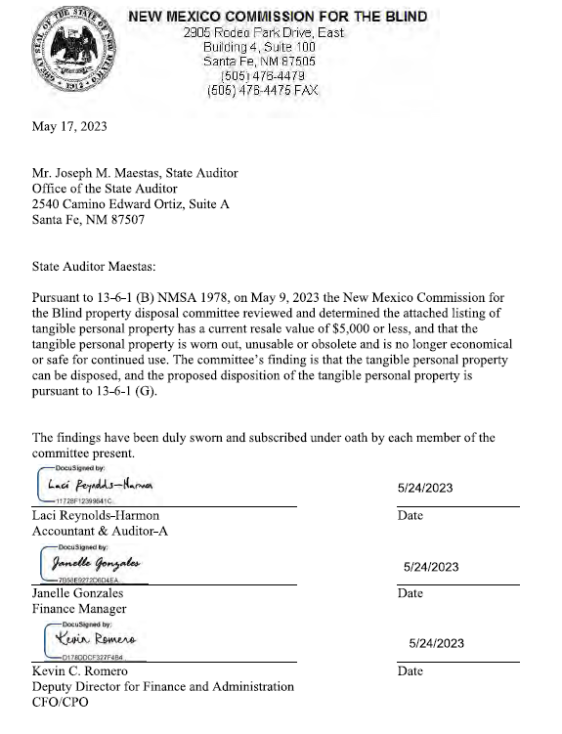

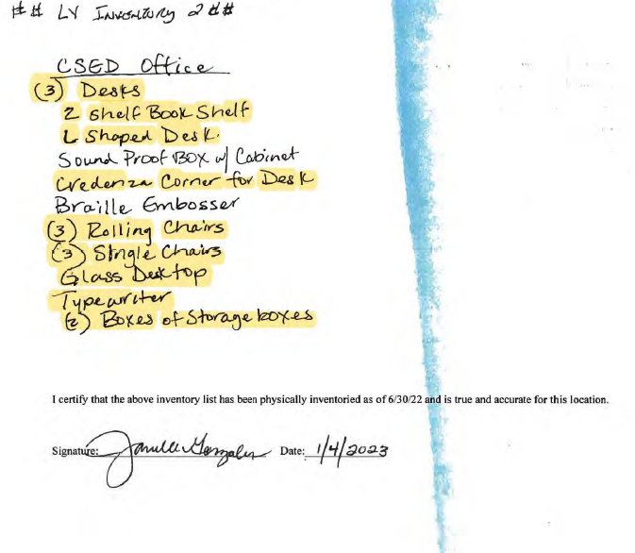

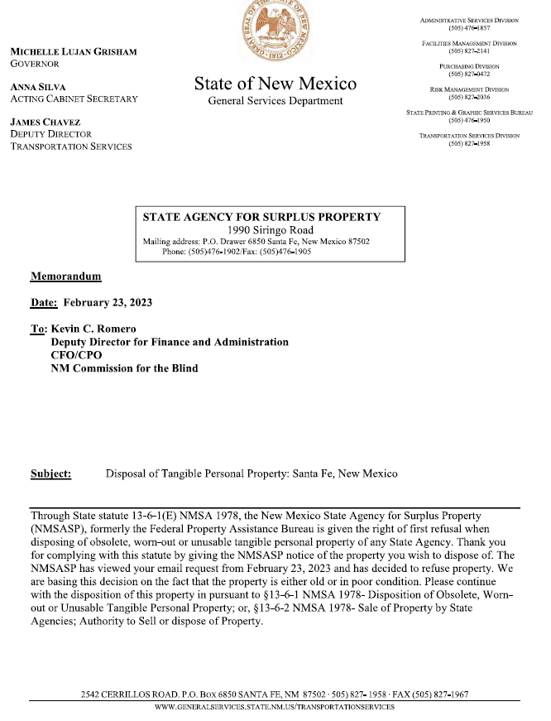

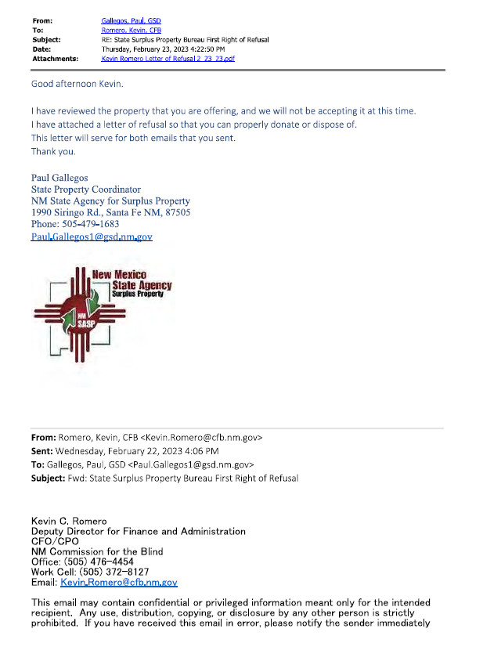
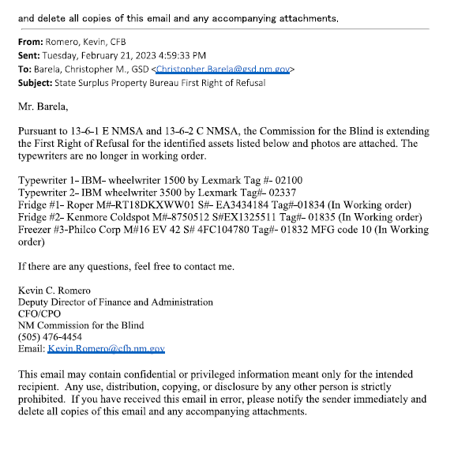

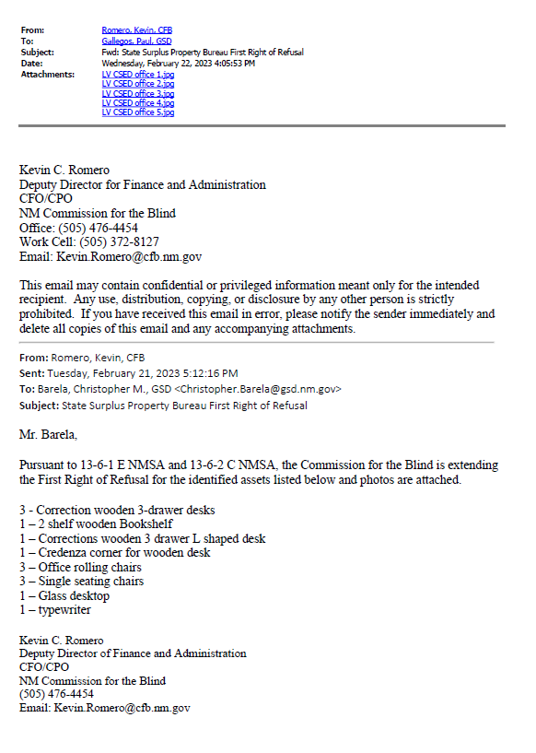

This email may contain confidential or privileged information meant only for the intended
recipient. Any use, distribution, copying, or disclosure by any other person is strictly
prohibited. If you have received this email in error, please notify the sender immediately and
delete all copies of this email and any accompanying attachments.

