New Mexico Commission for the Blind
MINUTES (Final)

Regular Meeting

Commission for the Blind
2905 Rodeo Park Drive East
Santa Fe, NM 87505

November 15, 2023 - 10:00 AM

1. Call to Order

Chairperson Lansing called the meeting to order at 10:05 AM.

2. Roll Call

Chairperson Lansing took roll, and Urja Lansing, Katharine Chavez, and Robert Reidy were present.

3. Introduction of Guests and Staff

Staff included Greg Trapp, Executive Director; Jim Salas, Deputy Director for Vocational Rehabilitation and Independent Living; Patricia Savage, Executive Secretary; Kelly Burma, Skills Center Coordinator; and Kevin Romero, Deputy Director for Finance and Administration. Attending by Zoom were Jamie Sibson, Orientation Center Director, and Daphne Mitchell, Vocational Rehabilitation Program Manager. Guest Dona Orgeron attended by Zoom.

4. Approval of Possible Changes to the Agenda Order and Tabling of Agenda Items

Mr. Trapp requested to move Ms. Sibson’s Orientation Center report to the first item under the director’s report.

Ms. Chavez moved to approve the agenda as revised, and Dr. Reidy seconded the motion. A vote was taken, and the revised agenda was unanimously approved.

5. Approval of Minutes for the Meeting of August 23, 2022

Dr. Reidy moved to approve the minutes, and Ms. Chavez seconded the motion. A vote was taken, and the minutes were unanimously approved.

6. Chair Report, Shirley “Urja” Lansing

Chairperson Lansing said on August 28 she attended the SFY23 entrance audit interview. She said on October 26 she was in Santa Fe and attended the Legislative Finance Committee hearing, where Director Trapp has always given an excellent and clear overview of the Agency’s programs. She said on October 30 she attended the SFY23 audit exit interview.

7. Election of Chair

Dr. Reidy nominated Ms. Lansing as Chairperson, and Ms. Chavez seconded the nomination. Chairperson Lansing called three times for other nominations, there were no other nominations, and Chairperson Lansing requested a motion that Ms. Lansing be elected by acclamation. Dr. Reidy moved that Ms. Lansing be elected by acclamation, and Ms. Chavez seconded the motion. A vote was taken, and the election of Ms. Lansing was unanimously approved.

Chairperson Lansing thanked the Commissioners and said she was honored to be of service.

8. Director’s Report, Greg Trapp

The Orientation Center Report from Ms. Sibson, Item 8 d, was taken next pursuant to the motion to approve the agenda.

Ms. Sibson said there are six students currently in training at the Orientation Center, with one expected to graduate before the winter break on December 19. She said one of the six students is going through the apprenticeship track to receive certification in rehabilitation teaching through the National Blindness Professional Certification Board. She said this student is also projecting to complete her training on December 19. She said one of the six students is a staff member who is receiving her immersion training. Ms. Sibson said there are two students in the apartments. She said another student will move in this week, and a fourth student is scheduled to move in after winter break.

Ms. Sibson said the Orientation Center received a certification visit from the National Blindness Professional Certification Board, adding that the Center has been certified for the next three years as a structured discovery center. Mr. Trapp congratulated Ms. Sibson on the recertification, and also on achieving her own NCUEB certification. Ms. Sibson said that two staff members also recently received their NCUEB certifications. Mr. Trapp said the Commission sponsors the NCUEB exam and it is great to have the Orientation Center and Skills Center staff so fully certified and accredited.

Chairperson Lansing said it is exciting to have three students in the apartments now.

Mr. Trapp said the VR counselors were recently in Alamogordo for training, and Ms. Sibson said she was excited to have the counselors at the Orientation Center and that she appreciated the partnership with the VR counselors. Mr. Trapp said he thinks it is important that the VR counselors see and appreciate the training center. He said the VR counselors make recommendations to their consumers and he has received positive comments from the VR counselors on their experiences at the center.

a. Major Trends and Developments, Greg Trapp

Mr. Trapp thanked Mr. Romero for hosting the meeting in Santa Fe, noting it was the first meeting in Santa Fe since the end of the pandemic. Mr. Trapp said the Santa Fe office is now home to both an IL teacher and a VR counselor. He said having a VR counselor and an IL teacher in Santa Fe is a much better alignment of resources considering the population of Santa Fe.

Mr. Trapp said that his wife, Tonia, was diagnosed with an aggressive form of cancer on August 30. He said he is monitoring how that impacts his own ability to perform as director. He said he decided not to attend the meetings of the National Council of State Agencies for the Blind, the National Coalition of State Rehabilitation Council, and the Council of State Administrators of Vocational Rehabilitation conferences in Savannah so that he could be with Tonia during her treatment. Mr. Trapp said his wife is scheduled to be at MD Anderson on January 8, and he hopes it does not conflict with the House Appropriations and Finance Committee hearing. Mr. Trapp added that if it does conflict, he is confident the Mr. Salas and Mr. Romero will very ably manage the HAFC meeting.

Mr. Trapp said it looks like Congress will be able to avoid a federal government shutdown. He said it looks like Speaker Johnson’s two-tiered budget approach is going to work, and that it passed the House with bipartisan support. He said he will continue to monitor the budget, and if it looks like there could be a shutdown the agency will make sure federal draws are as current as possible.

Mr. Trapp reported on the LFC hearing, saying it was held on October 27. He said he appreciated Dr. Reidy and Chairperson Lansing being present. He said he thought it went well. He said the final budget is approved by the House Appropriations and Finance Committee. He said the LFC analyst noted that the Commission had a clean audit. Mr. Trapp congratulated Mr. Romero and his staff for the clean audit. He said the Commission is in the midst of its current audit, which remains confidential until it is publicly released. He said the audit was submitted on time and hopes it will be released prior to the HAFC hearing.

Mr. Trapp said he spoke briefly at the last meeting about the Dear Colleague letter, the new interpretation from the U. S. Rehabilitation Services Administration on the definition of the word recipient, which determines how match is decided for the state. He said historically, the match has been based on an agency level, but now is based on a statewide level. He said as a state, New Mexico was able to match all of its federal funds, meaning the Commission was able to carry-over its federal fiscal year 2023 unspent funds. He said the National Council of State Agencies for the Blind executive committee met with the U.S. Assistant Secretary of Education, and he was assigned the task of leading that conversation by the NCSAB. He said the main concern was the reinterpretation of the word recipient and the fact that it might adversely impact the smaller blind agencies. He said there are 22 blind agencies, which means there are also 22 general agencies. He said if a much larger general agency does not meet its match requirement, and if the blind agency is unable to make up the difference on behalf of the state, then that blind agency will not be able to carry-over its federal funds. He said blind agencies will need to work very closely with general agencies on the state match. He said the DCL came out as a result of a question that had been submitted by the state of Maine. The Maine blind agency was unable to meet the match requirement and wanted to use the general agencies spending for match. He said RSA decided that the interpretation they had been applying for the last 22 years was in error, even though there have been prior waivers of the requirement. He said he was hoping RSA would issue regulations that would enable the ability to carry-over funds to be done either on an agency or statewide level. He said this would be consistent with maintenance of effort and Pre-ETS interpretations. He said there is a strong aversion by federal agencies to issue new regulations and that federal agencies are instead making policy through the issuance of sub-regulatory statements.

Mr. Trapp said the state is looking at the workforce case management systems, and that state workforce agencies use different case management programs. He said the Commission uses AWARE, which is used by 41 VR agencies across the country. He said a total of 36 states use AWARE. He said he would not want to move to an untested or unproven system.

Mr. Salas said he attended online meetings with the case management alignment facilitators. He said the meetings are national, and that the facilitators are trying to encourage partners to streamline the process through a common intake or a common referral process. He said he thinks there are things the Commission can do, while still maintaining the AWARE case management system that protects the confidentiality of consumer information. Mr. Salas said GeoSolutions is used by the Department of Workforce Solutions, and GeoSolutions offers a product that includes a VR module. He said there are only three VR agencies that are either using GeoSolutions or switching to GeoSolutions.

Mr. Trapp said the AWARE case management system used by the Commission has excellent report writing functionality, has an independent living module, and is accessible for screen reader and screen magnification users.

Mr. Trapp said the Commission is in the process of signing a state wage interchange system agreement, which will allow the Commission to access Department of Labor consumer wage data. He said this will enable the Commission to generate additional social security program income.

Mr. Trapp asked Ms. Mitchell if she had anything to add, and she said the Commission would be signing the Annex II document, which spells out how the data can be used and stored. She said the SWIS data would help improve the Commission’s report data for the second and fourth quarters after exit.

b. Administration and Finance, Kevin Romero

Mr. Romero reported on the Santa Fe lease RFP, saying a finalist has been selected. He said he is hoping to complete negotiations within the next 30 days. He said the agency is looking at a 10-year lease with two 5-year options. Mr. Romero said he thought it has been beneficial to have a VR counselor and IL teacher in the Santa Fe office, and that it has helped the agency to better meet the needs of consumers in the Santa Fe area.

Mr. Romero reported on federal funds, saying the agency has received a portion of the FY 24 award, amounting to approximately 25 percent of the total award. He said the agency is monitoring the progress of the budget in Congress. He said he is hoping the agency will receive the full appropriation in February, and that the agency will not have to worry about a potential shutdown. He said the agency monitors the budget to make sure it has drawn funds appropriately and can ride out any federal shutdown.

Mr. Romero reported on the FY 23 grant, saying that as of November 13, the Commission had expended 3,981,714 of the general VR funds, and $645,027 of the Pre-ETS reserve. He said this left $192,318 in FFY 23 Pre-ETS reserve, and $753,535 in the FFY 23 general VR funds that are yet to be expended. He said the Commission is projecting to fully utilize the FFY 23 VR grant, including the Pre-ETS reserve. He said the agency is working with DVR to make sure the state as a whole is able to meet the match and Pre-ETS requirements. Mr. Romero said that the agency also builds in a 20 percent under-utilization factor, meaning it assumes that some expenses will not materialize. He said that even with this under-utilization factor, the agency is still on track to fully spend the grant.

Reporting on the current state fiscal year, Mr. Romero said that as of this morning, the agency has expended $6,085,030, which is about 61 percent of the agency budget. He said the agency is on track to finish within budget on June 30. He said the agency has authority to also access fund balance.

Mr. Romero said the audit was submitted on time and that it is currently under review by the Office of the State Auditor. He said that DFA will also review the audit to make sure it aligns with the state financial ledger and to be sure that the Commission’s financial records were properly presented. He said the audit process is made more difficult due to the complexity of the federal grant. He said he hopes the audit will be publicly released in mid to late December.

Mr. Romero discussed the new Model of Accounting Practices requirement, saying that the auditors will be testing for MAPS violations. He said that MAPS violations will be presented as audit findings. Mr. Romero gave the example of the MAPPS requirement that travel reimbursements be submitted within 14 days, saying failure to do so is technically a MAPS violation. He said that he thought the submission of a justifying white paper in the case of a late justification should not be a MAPS violation. Mr. Romero said the Commission would engage in due diligence to avoid MAPS violations, that the agency works to be in compliance with rules and statutes, will provide training should there be a finding, and will work to maximize the taxpayer benefit.

Mr. Trapp said that the new MAPS requirement increases the likelihood of audit findings, but that any increase in audit findings will not reflect any negligence or lack of internal controls. He said that any such findings would not be material.

Mr. Romero reported on the state budget request, saying the Commission was seeking an 8 percent increase in general funds, which was an increase of $210,000. He said this would be used to match additional federal funds and support the independent living program, and would be a part of the base budget going forward. He said that the budget is assuming a 15.6 percent vacancy rate, meaning that about 15 percent of the personnel costs will not materialize. He said this is a reduction from the prior year, and shows that the agency is being proactive in how it manages the budget. He said the agency is waiting for the LFC and Executive recommendations, which he said will likely come out about a week before the start of the session.

Ms. Lansing commended Mr. Romero and the staff for the management and tracking of finances, noting that the finances are extremely complicated.

c. Independent Living and Vocational Rehabilitation, Jim Salas

Mr. Salas reported on personnel items, saying that Mr. Deon Dodson retired in September after a career of over 25 years. He said he was very sorry to see him leave, and expressed his appreciation for his service to the agency’s consumers. He said that Nathalie Martin was hired to be the new IL teacher in Farmington. Mr. Salas said there was an IL teacher vacancy in Las Cruces, noting that Las Cruces has two IL teachers. He said he would be interviewing for that vacancy on Monday. Mr. Salas said the IL program has had a 100 percent turnover in the last two years. He said this was primarily due to the retirement of long time IL teachers. Mr. Salas said he thinks the IL team has a really good group of new IL teachers. He said one of those is Gerrard McGill, the IL teacher in the Santa Fe office.

Mr. Salas said that his team is working on the submission of federal reports, saying that the RSA-911 report is due today. He said the RSA-911 is submitted quarterly, and that this particular report is for the first quarter of the federal program year and the last quarter of the federal fiscal year. He said Audrey Trujillo and Daphne Mitchell work on the RSA-911. He said the Commission is also working on the RSA-7O4 and RSA 7OB independent living reports, which he said are due at the end of the year. He said the RSA-7O4 is a joint report for the Commission and DVR, and the Older Blind report is submitted by the Commission. He said the agency is also working on the RSA-15 which is for the Business Enterprise Program.

Mr. Salas reported on the VR program for the current state fiscal year that started on July 1, saying nine consumers were placed in competitive and integrated employment and one consumer was placed in self-employment, for a total of ten consumers placed in employment. He said their average starting wage was $25.77 an hour.

Mr. Salas said the really good numbers were for the federal fiscal year that ended on September 30. He said 29 consumers were placed in competitive and integrated employment and one consumer was placed in self-employment, for a total of 30. He said it has been 12 years since 30 consumers were placed in employment during either a state or federal fiscal year. He said their average starting wage was $22.95 an hour. Mr. Salas said 24 additional consumers were in employment status, meaning they were employed and had a stable date, and 21 consumers were in Service E, meaning that they were employed but do not have a stable date. He said this was a potential of 45 additional rehab closures. Mr. Salas emphasized that these were fantastic employment numbers.

Dr. Reidy congratulated the agency and thanked the entire team for their efforts, saying he has been around for many years and that these are the best numbers he has seen. Ms. Lansing offered her own congratulations to the staff.

d. Orientation Center, Jamie Sibson

Ms. Lansing said this item was taken earlier in the meeting.

e. Skills Center, Kelly Burma

Ms. Burma reported on the Skills Center, saying three Pre-ETS students were served through evaluations and virtual and in-person instruction. She said the Skills Center is currently serving two adults. Ms. Burma said the Skills Center hosted a forensics science camp on September 15 and 16. She said a total of seven Pre-ETS students attended the in-person science camp. She said the breakroom was turned into a crime scene and that the students analyzed the crime scene using a variety of criminal procedure and scientific methods. She said the students included persons who were interested in science, as well as entertainment and mystery writing. She said the contractor was Independence Science.

Ms. Burma said the Skills Center hosted a seminar on Unified English Braille on September 22. She said Casey West Robertson presented the seminar. Ms. Burma said she also conducted a NCUEB test at the Orientation Center in Alamogordo. Ms. Burma said three children have been served this state fiscal year through the technology for children program, and that additional applications are being taken statewide. She said she has attended IEP meetings, and provided other support for students.

Mr. Trapp thanked Ms. Burma for presenting on the conducting of Council meetings at the National Coalition of State Rehabilitation Councils in Savanah. He said they were originally supposed to co-present, but that she had to do the whole presentation since he was unable to attend. He said the topic included virtual meetings and open meetings laws.

9. Unfinished Business

a. Update on Rehabilitation Services Administration Pre-ETS Annual Review Finding, Greg Trapp, Kevin Romero, and Jim Salas

Mr. Trapp reported on the finding, noting that Mr. Romero said in his report that the Commission was on track to spend all of the FFY 23 federal VR grant, including the 15 percent Pre-ETS reserve. Mr. Trapp said the finding was largely due to the impact of the pandemic on Pre-ETS spending, and some report issues that took place at DVR. He said the corrective action plan has been submitted and accepted by RSA. Mr. Trapp said Mr. Romero submitted excellent supporting documentation on the Commission’s Pre-ETS spending.

Mr. Romero said the agency is now working more closely with DVR to meet the Pre-ETS reserve, adding that it is a statewide requirement.

Mr. Trapp said the Pre-ETS finding was due to a perfect storm of circumstances. He said the Dear Colleague Letter may also impact on the ability of the agency to meet the reserve if the Commission is unable to carry over and spend the Pre-ETS funds to the second year of the period of performance.

b. Update on State Plan, Greg Trapp and Jim Salas

Mr. Trapp said the agency was able to get the Commission’s portion of the Combined State Plan to the Department of Workforce Solutions, and that the State Rehabilitation Council will be meeting tomorrow to take care of any issues that may need to be addressed with respect to the state plan, including any issues that RSA may belatedly require.

Mr. Salas said he read the most recent RSA guidance that came out two weeks ago, and that the guidance did not impose any additional requirements that still need to be addressed in the plan. He said he listened to an RSA state plan training that came out at the end of September, and that he wanted to go back and revise the plan to better address some technical requirements, noting that the plan had been submitted to Workforce Solutions at the start of October. He said there is plenty of time to do this since the plan is not due until March 4.

10. New Business

a. Discussion of Strategic Plan, Greg Trapp

Mr. Trapp said the strategic plan is a part of the agency request budget. He said the current strategic plan is valid until later in 2024. He said that the pandemic has made some significant changes to the workforce, as well as impacting on diabetic retinopathy and glaucoma. He said that COVID has been shown to cause new cases of diabetes, which will result in more cases of blindness due to diabetic retinopathy. He said COVID has caused an increase in premature births, which will result in increased cases of blindness. He said COVID has in rare cases caused blindness, and that the long-term impact of COVID is not yet known since COVID can impact on the micro-circulatory system.

Dr. Reidy said the understanding of COVID is evolving, including the impact of long COVID. He said it is being studied extensively.

Mr. Trapp said studies of the 1918 flu have shown that there was a very large increase in the number of persons who were entered into what were known at the time as asylums or sanitariums in the wake of the 1918 flu. He said there will be an impact on the VR program due to COVID, and that the strategic plan needs to address that impact. He said the strategic plan needs to address remote work and the aging of the workforce. He said the pandemic had a very significant impact on students, including the provision of Braille and Orientation and mobility instruction. He said the agency will see an increase in the population of persons who are blind who do not have Braille and literacy skills, and that this impact will be seen in the decades to come.

Ms. Burma commented on the increase of children with optic nerve hypoplasia, brain tumors, and mental health issues. She said that even before the pandemic children who are blind were severely behind their sighted peers in terms of literacy skills.

Mr. Trapp agreed that the mental health issue was a serious concern for students, and that this concern has been increased due to the pandemic and also due to the physical effects of COVID on mental health.

Mr. Trapp said the Commission would discuss the strategic plan with the State Rehab Council, and likely also during a public meeting. He said the strategic plan would be revised in the spring, and the new strategic plan would be submitted with the request budget. He said it would be for a five-year term. Mr. Trapp concluded by talking about trends in the medical treatment of blindness, saying that while treatment is advancing and may result in less severe cases of blindness, including stem cell research and treatment, there is not yet a cure for blindness.

b. Discussion of Federal Monitoring, Greg Trapp

Mr. Trapp said that the federal government monitors VR agencies under Section 107 of the Rehabilitation Act. He said the annual review is one way in which VR agencies are monitored under Section 107. He said the other is through a much more intensive on-site monitoring, which the Commission has not undergone since 2010. Mr. Trapp said the Commission periodically conducts its own internal test monitoring using the federal Monitoring and Technical Assistance Guidelines. Mr. Trapp said the federal government has just announced the states to be monitored and the Commission is again not selected for monitoring. He said he thinks this is a complement to the agency’s fiscal and program team. He said the federal government, in deciding what agencies to monitor, considers the degree to which the entire grant is being spent. Mr. Trapp noted that Mr. Romero reported earlier in the meeting that the agency would spend the entire FFY 23 VR grant. Mr. Trapp said vocational rehabilitation is a $3.7 billion program at the national level, and that VR agencies are returning about $500 million in unspent funds. Mr. Trapp said the other item the feds consider is the risk an agency presents to the federal interest. He said an agency will be considered to be at increased risk if it is not submitting accurate and timely reports, or if its state audits contain material findings.

c. Discussion of Update to BEP Manual, Greg Trapp and Jim Salas

Mr. Trapp said the Business Enterprise Manual was last updated around 1997. He said it is promulgated as a state rule, meaning it is part of the State Administrative Code. He said this means that updating the manual is more cumbersome. He said the agency is also required to actively participate with the Committee of Blind Vendors in the updating of the manual. He said the agency has been doing this, and is having conversations with the Committee of Blind Vendors about the proposed update. Mr. Trapp said the plan is to hire a consultant to help with the process. He said he is hoping to adopt a manual model that the federal government has already approved and to avoid wordsmithing the current manual. Mr. Trapp said the manual must be approved by the Rehabilitation Services Administration. He said the agency must also comply with the State Rules Act, which requires that the manual go out for public comment.
Mr. Salas said that the blind managers are very supportive of the proposed process. He said the plan is to work with Terry Smith, who is the former director of the Tennessee agency and is very knowledgeable about the Randolph-Sheppard Act.

Mr. Trapp said he wants to get the manual updated before he retires. He said the manual does need to be revised, and that he wants to be sure it is compliant.

Ms. Lansing asked what will go out to public comment, and Mr. Trapp said the whole manual. He said he believes that the agency will work with the vendors to update the manual as a part of the active participation process, that the revised manual will be submitted to the feds for their approval, and that the manual will then be put out for public comment as a part of the state rule process. He said that the agency will go back to the feds for final approval should there be changes made as a result of the public comment process.

c. Report of Property Disposition Committee, Kevin Romero

Mr. Romero said the number of requests to the committee for property disposition has been increasing, and that the committee will be meeting to review requests the second and fourth Fridays of each month. Mr. Romero said the committee would be preparing a property disposition guide that will go out to ensure that employees are aware of the process.

Mr. Romero reported on property disposals, saying that IT equipment from the Skills Center was reviewed by the committee. He said it was determined that the equipment was obsolete and no longer of use to the Commission and was recommended for disposal. He said the notice was sent to the Office of the state Auditor on June 26. Mr. Romero reported on equipment from the Business Enterprise Program that was recommended for disposal through an auction process. He said parts for the equipment were no longer available and that the committee determined that the equipment was obsolete and no longer of use to the Commission. He said a notice was sent to the Office of the State Auditor on September 27. Mr. Romero said the committee received a request for property disposition from Albuquerque, and that two items, a table saw and rolling step ladder, were determined by State Surplus to be of use to the state and were retained. He said the remainder of the items were determined to no longer be of use to the Commission and that a property disposition letter was sent to the Office of the State Auditor on September 27. Mr. Romero reported on an after-the-fact review by the committee of the disposition of a couch out of the Albuquerque office. He said it was disposed of through transfer to the Correction Industries Division, which had delivered the replacement couch. Mr. Romero said the committee determined that the disposition of the couch was to another state agency and was appropriate. He said a notice was sent to the Office of the State Auditor on October 3. Mr. Romero said that thirty days have elapsed from the dates of the notifications to the Office of the State Auditor, and that as a result all of the property is now eligible for appropriate disposition.
Mr. Romero discussed the proposed guide, and what types of property must go through the committee for disposition. Mr. Romero said the statute and administrative code were not very clear. He gave the example of the couch, saying the Office of the State Auditor said notification was not necessary because the couch was below the dollar amount, but Mr. Romero noted that the statute and rule do not specify a dollar amount. He said the statute says all tangible property. Mr. Romero said the goal of the guide is to be consistent and make sure everyone is on the same page.

Ms. Chavez asked who was on the committee, and Mr. Romero said there are four persons on the Committee. He said he is on the committee, along with the Finance Manager, the Accountant Auditor, and the Business Operations Specialist. He said the Commission created the committee to act on behalf of the Commission, and without the committee each disposition would have to be approved by the Commission, significantly delaying the process.

Mr. Trapp said the statute is poorly written, and that it is difficult to determine the actual intent of the statute. He said he believes the best interpretation of the statute is for the committee to be authorized by the Commission to dispose of property after a notification to the Office of the State Auditor, and for the committee to make reports to the Commission on property disposition with the process being captured in the minutes.

11. Commission Open Discussion

There was no Commission Open Discussion.

12. Comments from the Audience

There were no comments from the audience.

13. Date and Location of Next Meeting

The next meeting was set for Santa Fe at 10:00 AM on January 23. The following meeting was set for Santa Fe at 10:00 AM on April 23.

14. Adjourn

Ms. Lansing adjourned the meeting at 1:05 PM.

Approved and Electronically Signed This 23rd Day of January 2024.

Urja Lansing, Chairperson
New Mexico Commission for the Blind

Attachments

June 26 OSA Notice
September 27 OSA Notice (BEP)
September 27 OSA Notice (Albuquerque)
October 3 OSA Notice

Attachment 1 - June 26 OSA Notice

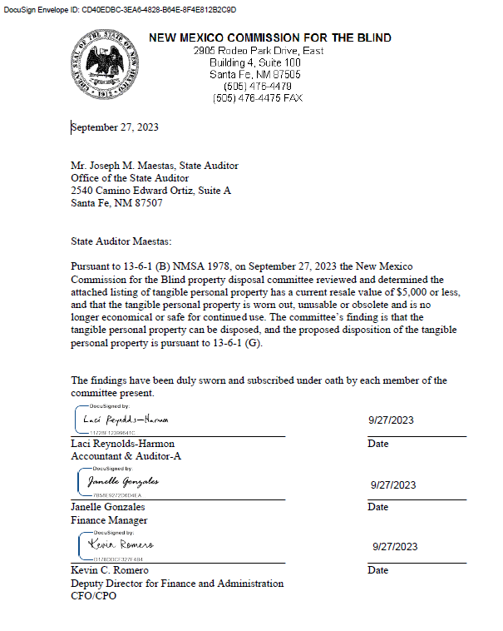

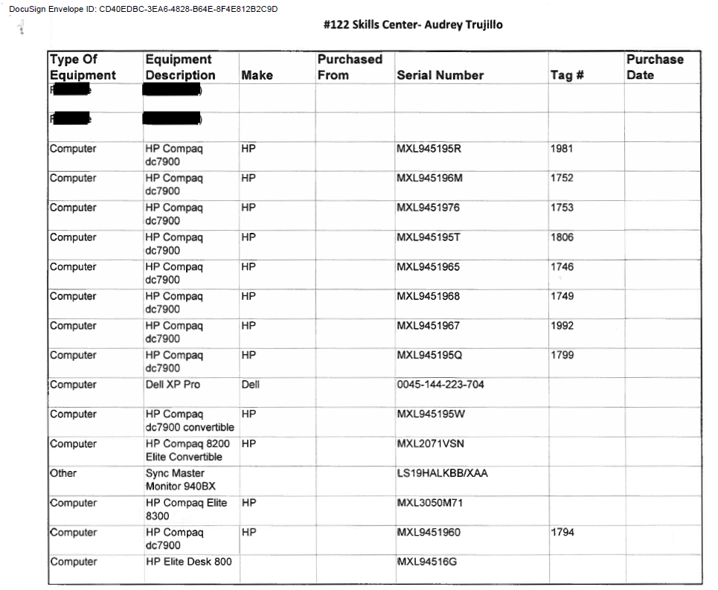

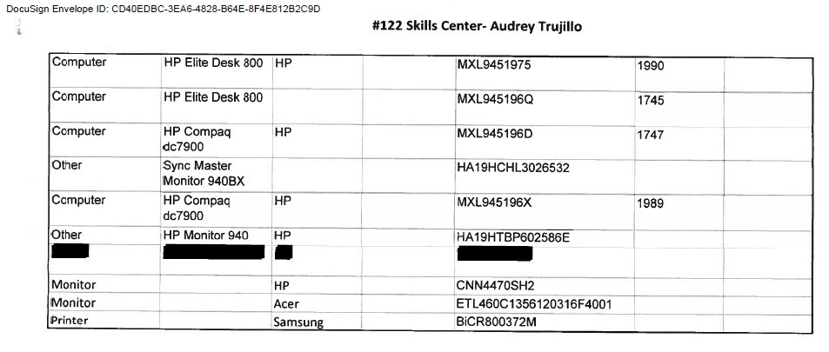

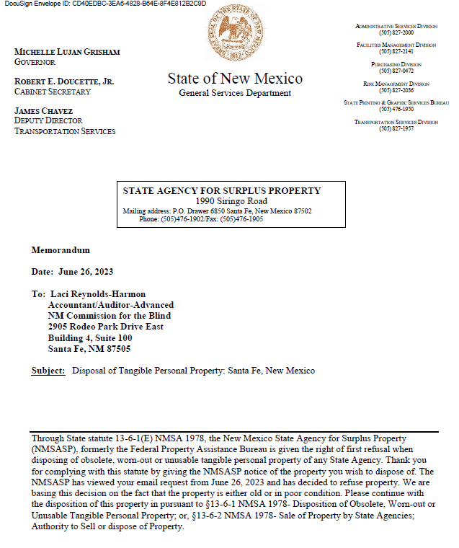

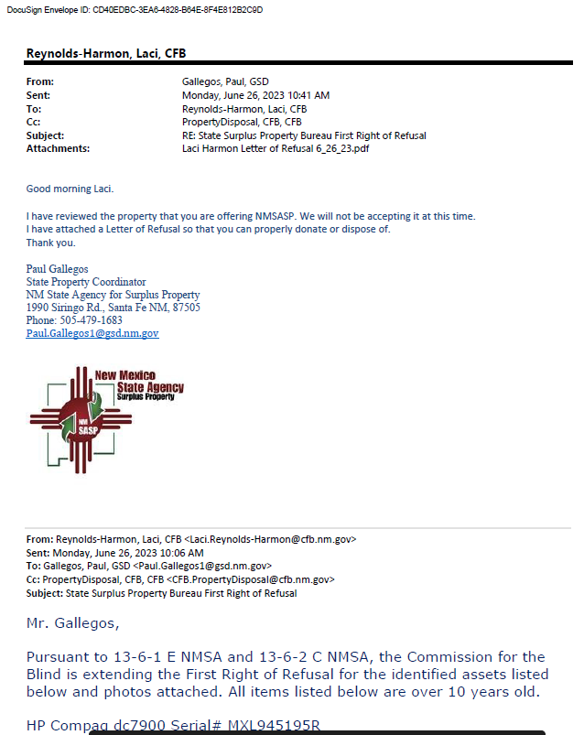

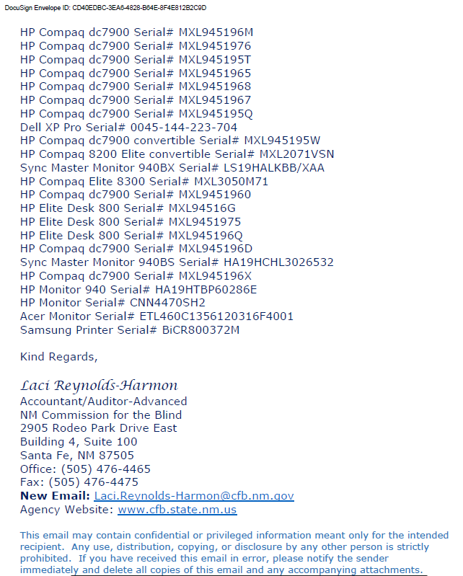

Attachment 2 - September 27 OSA Notice (BEP)

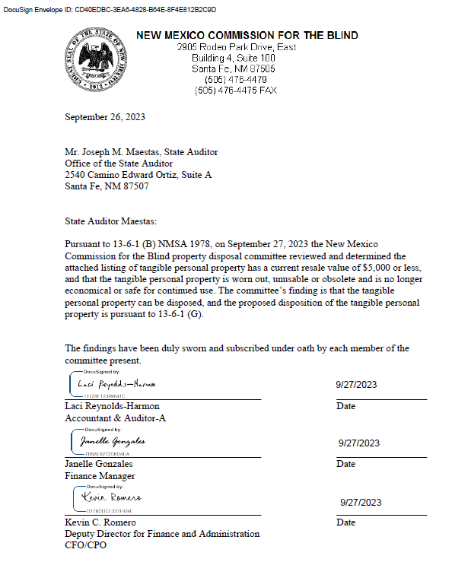

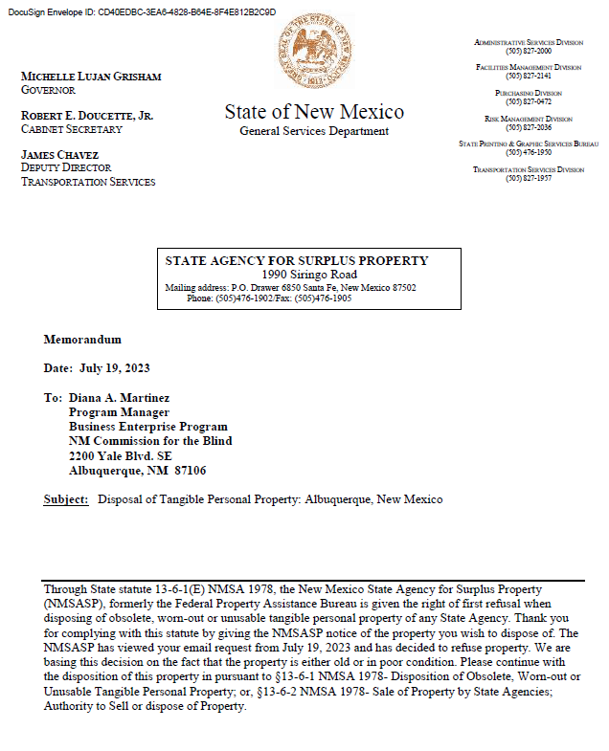

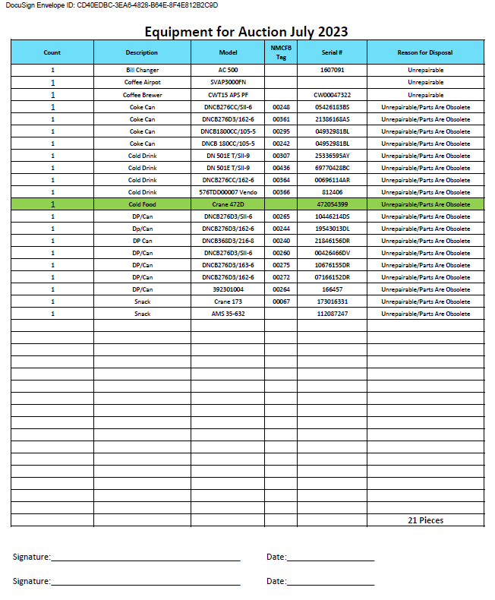

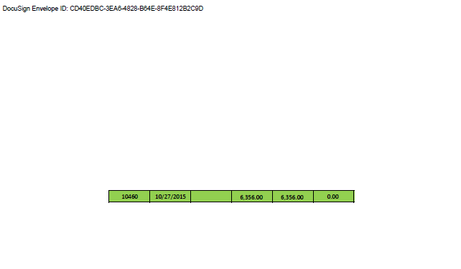

Attachment 3 - September 27 OSA Notice (Albuquerque)

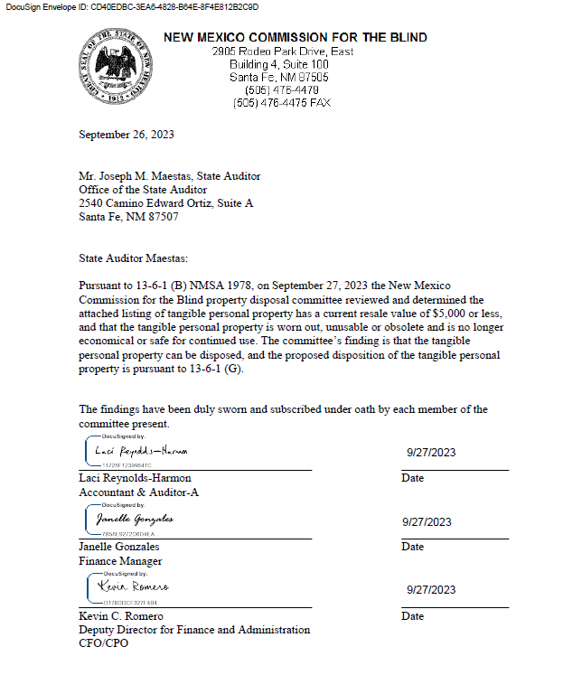

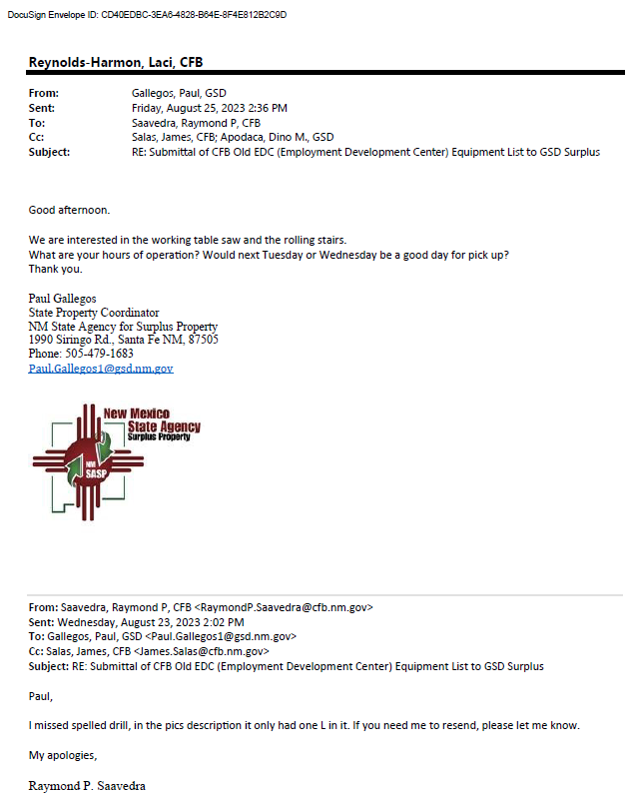

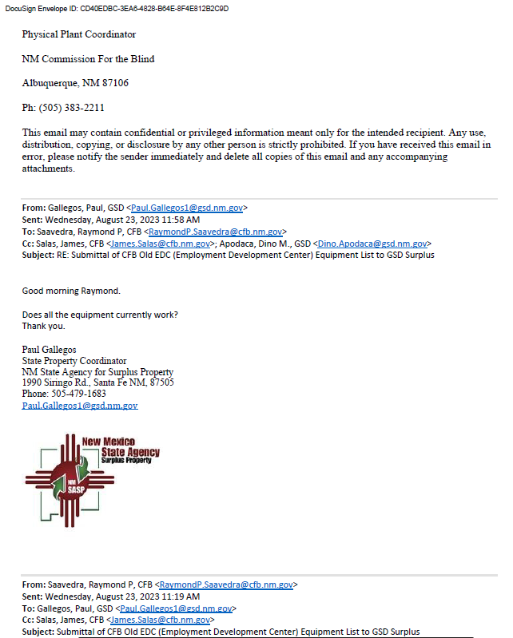

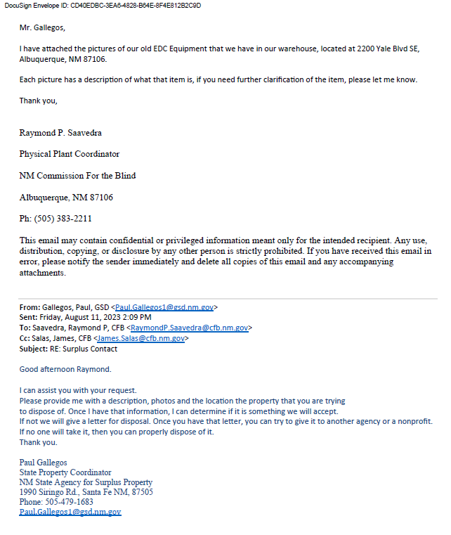

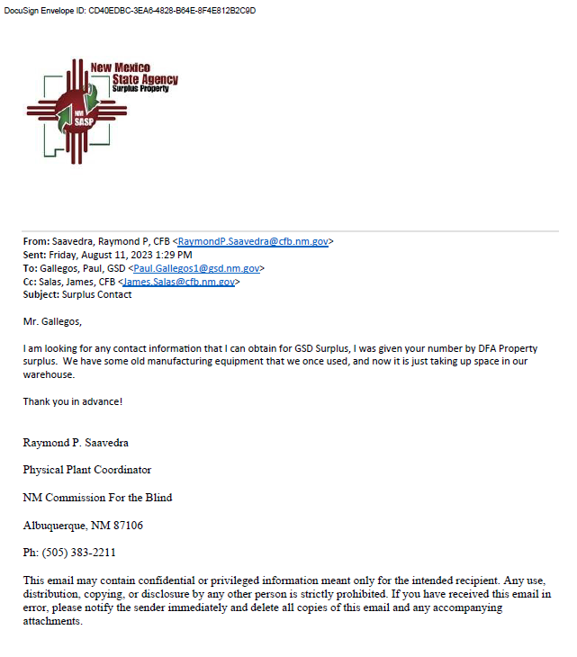

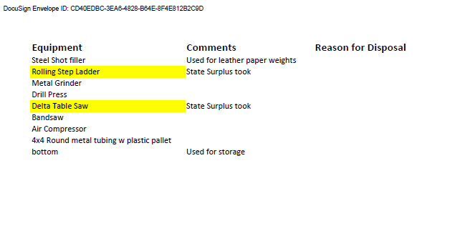

Attachment 4 -October 3 OSA Notice

